Project Notes 1 & 2

Problem Statement
An aviation company that provides domestic as well as international trips to the customers now wants to apply a targeted approach instead of reaching out to each of the customers. This time they want to do it digitally instead of tele-calling. Hence they have collaborated with a social networking platform, so they can learn the digital and social behavior of the customers and provide the digital advertisement on the user page of the targeted customers who have a high propensity to take up the product. Propensity of buying tickets is different for different login devices. Hence, you have to create 2 models separately for Laptop and Mobile.
NOTE: Anything which is not a laptop can be considered as mobile phone usage.
NOTE: The advertisements on the digital platform are bit expensive, hence you need to be very accurate while creating the models.

Importing Libraries and Checking the Data :-
#Importing basic Libraries
import numpy as np
import pandas as pd
import seaborn as sns
import matplotlib.pyplot as plt
%matplotlib inline
#to ignore warnings
import warnings
warnings.filterwarnings('ignore')
#Loading the dataset
data = pd.read_csv(r'D:\SHUBHANK !\GL\My_Capstone_Project\Social Media Data for DSBA.csv')

Exploring the data :-
#Reading the head of the dataset
data.head().T
0 1 \
UserID 1000001 1000002
Taken_product Yes No
Yearly_avg_view_on_travel_page 307.0 367.0
preferred_device iOS and Android iOS
total_likes_on_outstation_checkin_given 38570.0 9765.0
yearly_avg_Outstation_checkins 1 1
member_in_family 2 1
preferred_location_type Financial Financial
Yearly_avg_comment_on_travel_page 94.0 61.0
total_likes_on_outofstation_checkin_received 5993 5130
week_since_last_outstation_checkin 8 1
following_company_page Yes No
montly_avg_comment_on_company_page 11 23
working_flag No Yes
travelling_network_rating 1 4
Adult_flag 0 1
Daily_Avg_mins_spend_on_traveling_page 8 10
2 3 \
UserID 1000003 1000004
Taken_product Yes No
Yearly_avg_view_on_travel_page 277.0 247.0
preferred_device iOS and Android iOS
total_likes_on_outstation_checkin_given 48055.0 48720.0
yearly_avg_Outstation_checkins 1 1
member_in_family 2 4
preferred_location_type Other Financial
Yearly_avg_comment_on_travel_page 92.0 56.0
total_likes_on_outofstation_checkin_received 2090 2909
week_since_last_outstation_checkin 6 1
following_company_page Yes Yes
montly_avg_comment_on_company_page 15 11
working_flag No No
travelling_network_rating 2 3
Adult_flag 0 0
Daily_Avg_mins_spend_on_traveling_page 7 8
4
UserID 1000005
Taken_product No
Yearly_avg_view_on_travel_page 202.0
preferred_device iOS and Android
total_likes_on_outstation_checkin_given 20685.0
yearly_avg_Outstation_checkins 1
member_in_family 1
preferred_location_type Medical
Yearly_avg_comment_on_travel_page 40.0
total_likes_on_outofstation_checkin_received 3468
week_since_last_outstation_checkin 9
following_company_page No
montly_avg_comment_on_company_page 12
working_flag No
travelling_network_rating 4
Adult_flag 1
Daily_Avg_mins_spend_on_traveling_page 6
#Printing the shape and size of the dataset
print('Total Columns: ',data.shape[1])
print('Total Rows: ',data.shape[0])
#Size of the dataset
print('\nSize of the data:',data.size)
Total Columns: 17
Total Rows: 11760
Size of the data: 199920
#Let see all the names of the columns in the dataset
print('Names of the columns:-\n\n',data.columns)
Names of the columns:-
Index(['UserID', 'Taken_product', 'Yearly_avg_view_on_travel_page',
'preferred_device', 'total_likes_on_outstation_checkin_given',
'yearly_avg_Outstation_checkins', 'member_in_family',
'preferred_location_type', 'Yearly_avg_comment_on_travel_page',
'total_likes_on_outofstation_checkin_received',
'week_since_last_outstation_checkin', 'following_company_page',
'montly_avg_comment_on_company_page', 'working_flag',
'travelling_network_rating', 'Adult_flag',
'Daily_Avg_mins_spend_on_traveling_page'],
dtype='object')

Renaming few of the columns for better readability and understanding:-
Replacing few long words in short abbreviations, like:
- Yearly_avg as YA
- Daily_avg as DA
- Preffered as Pref
- Total_likes as TL
- Monthly_avg as MA
- Outstation or out of station are same, so replacing it with OS
- Travel_page and Company_page are same, so replacing it with CP
data.rename({'Yearly_avg_view_on_travel_page': 'YA_view_on_CP',
'preferred_device': 'pref_device',
'total_likes_on_outstation_checkin_given': 'TL_done_on_OS_checkin',
'yearly_avg_Outstation_checkins' : 'YA_OS_checkin',
'member_in_family' : 'members_in_fam',
'preferred_location_type' : 'pref_loc_type',
'Yearly_avg_comment_on_travel_page' : 'YA_comment_on_CP',
'total_likes_on_outofstation_checkin_received' : 'TL_rec_on_OS_checkin',
'week_since_last_outstation_checkin' : 'week_since_last_OS_checkin',
'following_company_page' : 'following_CP',
'montly_avg_comment_on_company_page':'MA_comment_on_CP',
'Daily_Avg_mins_spend_on_traveling_page' : 'DA_mins_spend_on_CP'}, axis=1, inplace=True)
#Now again checking columns and shape
print(data.shape)
print('\n---------------')
new_column_names = data.columns
print(new_column_names)
(11760, 17)
---------------
Index(['UserID', 'Taken_product', 'YA_view_on_CP', 'pref_device',
'TL_done_on_OS_checkin', 'YA_OS_checkin', 'members_in_fam',
'pref_loc_type', 'YA_comment_on_CP', 'TL_rec_on_OS_checkin',
'week_since_last_OS_checkin', 'following_CP', 'MA_comment_on_CP',
'working_flag', 'travelling_network_rating', 'Adult_flag',
'DA_mins_spend_on_CP'],
dtype='object')
#Let's look at the basic information about the dataset
data.info()
<class 'pandas.core.frame.DataFrame'>
RangeIndex: 11760 entries, 0 to 11759
Data columns (total 17 columns):
# Column Non-Null Count Dtype
--- ------ -------------- -----
0 UserID 11760 non-null int64
1 Taken_product 11760 non-null object
2 YA_view_on_CP 11179 non-null float64
3 pref_device 11707 non-null object
4 TL_done_on_OS_checkin 11379 non-null float64
5 YA_OS_checkin 11685 non-null object
6 members_in_fam 11760 non-null object
7 pref_loc_type 11729 non-null object
8 YA_comment_on_CP 11554 non-null float64
9 TL_rec_on_OS_checkin 11760 non-null int64
10 week_since_last_OS_checkin 11760 non-null int64
11 following_CP 11657 non-null object
12 MA_comment_on_CP 11760 non-null int64
13 working_flag 11760 non-null object
14 travelling_network_rating 11760 non-null int64
15 Adult_flag 11760 non-null int64
16 DA_mins_spend_on_CP 11760 non-null int64
dtypes: float64(3), int64(7), object(7)
memory usage: 1.5+ MB
#Description of the data and five number summary using describe function
pd.set_option('display.float_format', lambda x: '%.2f' % x) #Keeping the decimal points upto 2 places
data.describe().T
count mean std min 25% \
UserID 11760.00 1005880.50 3394.96 1000001.00 1002940.75
YA_view_on_CP 11179.00 280.83 68.18 35.00 232.00
TL_done_on_OS_checkin 11379.00 28170.48 14385.03 3570.00 16380.00
YA_comment_on_CP 11554.00 74.79 24.03 3.00 57.00
TL_rec_on_OS_checkin 11760.00 6531.70 4706.61 1009.00 2940.75
week_since_last_OS_checkin 11760.00 3.20 2.62 0.00 1.00
MA_comment_on_CP 11760.00 28.66 48.66 11.00 17.00
travelling_network_rating 11760.00 2.71 1.08 1.00 2.00
Adult_flag 11760.00 0.79 0.85 0.00 0.00
DA_mins_spend_on_CP 11760.00 13.82 9.07 0.00 8.00
50% 75% max
UserID 1005880.50 1008820.25 1011760.00
YA_view_on_CP 271.00 324.00 464.00
TL_done_on_OS_checkin 28076.00 40525.00 252430.00
YA_comment_on_CP 75.00 92.00 815.00
TL_rec_on_OS_checkin 4948.00 8393.25 20065.00
week_since_last_OS_checkin 3.00 5.00 11.00
MA_comment_on_CP 22.00 27.00 500.00
travelling_network_rating 3.00 4.00 4.00
Adult_flag 1.00 1.00 3.00
DA_mins_spend_on_CP 12.00 18.00 270.00
#Checking the data type for each variable in the dataset
data.dtypes
UserID int64
Taken_product object
YA_view_on_CP float64
pref_device object
TL_done_on_OS_checkin float64
YA_OS_checkin object
members_in_fam object
pref_loc_type object
YA_comment_on_CP float64
TL_rec_on_OS_checkin int64
week_since_last_OS_checkin int64
following_CP object
MA_comment_on_CP int64
working_flag object
travelling_network_rating int64
Adult_flag int64
DA_mins_spend_on_CP int64
dtype: object
#Any null or missing values in dataset ?? Let's check
data.isnull().any()
UserID False
Taken_product False
YA_view_on_CP True
pref_device True
TL_done_on_OS_checkin True
YA_OS_checkin True
members_in_fam False
pref_loc_type True
YA_comment_on_CP True
TL_rec_on_OS_checkin False
week_since_last_OS_checkin False
following_CP True
MA_comment_on_CP False
working_flag False
travelling_network_rating False
Adult_flag False
DA_mins_spend_on_CP False
dtype: bool
Boolean value False means there is no missing data in the column and True means there are some missing values in that column.
#Yes, there are missing values in the dataset.
#let's check how many missing values are there in those columns
data.isnull().sum()
UserID 0
Taken_product 0
YA_view_on_CP 581
pref_device 53
TL_done_on_OS_checkin 381
YA_OS_checkin 75
members_in_fam 0
pref_loc_type 31
YA_comment_on_CP 206
TL_rec_on_OS_checkin 0
week_since_last_OS_checkin 0
following_CP 103
MA_comment_on_CP 0
working_flag 0
travelling_network_rating 0
Adult_flag 0
DA_mins_spend_on_CP 0
dtype: int64
#Total count of the missing values
print('Total missing values:',data.isnull().sum().sum())
Total missing values: 1430

Data Cleaning :-

Dropping 2 columns that are not useful for our analysis :-
#First of all dropping the UserID column as it is not so useful for our analysis
#Also we are dropping montly_avg_comment_on_company_page column bceause we already have yearly_avg comment column because
#it does not make sense to keep both columns as it is indicating same action
data.drop(['UserID','MA_comment_on_CP'], axis = 1, inplace = True)

Treating Missing Values :-
#While checking, we've got 1430 total missing values in the dataset, which is around 12% of the total records
#So we decide not to do any random imputation because it may affect our model
#Lets just drop them all
data.dropna(inplace=True)
#After dropping, Let's check the null values again
data.isnull().sum()
Taken_product 0
YA_view_on_CP 0
pref_device 0
TL_done_on_OS_checkin 0
YA_OS_checkin 0
members_in_fam 0
pref_loc_type 0
YA_comment_on_CP 0
TL_rec_on_OS_checkin 0
week_since_last_OS_checkin 0
following_CP 0
working_flag 0
travelling_network_rating 0
Adult_flag 0
DA_mins_spend_on_CP 0
dtype: int64
Now all the null values are dropped from the dataset.
#Let's check the shape and info again
print('Total Columns: ',data.shape[1])
print('Total Rows: ',data.shape[0])
print('\n------------')
data.info()
Total Columns: 15
Total Rows: 10456
------------
<class 'pandas.core.frame.DataFrame'>
Int64Index: 10456 entries, 0 to 11759
Data columns (total 15 columns):
# Column Non-Null Count Dtype
--- ------ -------------- -----
0 Taken_product 10456 non-null object
1 YA_view_on_CP 10456 non-null float64
2 pref_device 10456 non-null object
3 TL_done_on_OS_checkin 10456 non-null float64
4 YA_OS_checkin 10456 non-null object
5 members_in_fam 10456 non-null object
6 pref_loc_type 10456 non-null object
7 YA_comment_on_CP 10456 non-null float64
8 TL_rec_on_OS_checkin 10456 non-null int64
9 week_since_last_OS_checkin 10456 non-null int64
10 following_CP 10456 non-null object
11 working_flag 10456 non-null object
12 travelling_network_rating 10456 non-null int64
13 Adult_flag 10456 non-null int64
14 DA_mins_spend_on_CP 10456 non-null int64
dtypes: float64(3), int64(5), object(7)
memory usage: 1.3+ MB
Now there are 10456 records and no null/missing values present.

Dropping the rows which has special characters :-
While checking the dataset, we found out that there is a special character in the column 'YA_OS_checkin'. So let's drop the rows with special character.
#First checking the row with special character in the column
data[data.YA_OS_checkin.str.contains(r'[@#&$%+-/*]')]
#dropping the complete row
data.drop(data[data.YA_OS_checkin.str.contains(r'[^0-9a-zA-Z]')].index, inplace=True)
#reprinting the shape now
data.shape
(10455, 15)
Now we are left with 10455 rows and 15 columns.

Let's do the Univariate Analysis :-
#Taken_product (Whether the user has taken their product or not)
print(data.Taken_product.value_counts())
print('\n---------------')
print('Proportion:\n\n',data.Taken_product.value_counts(normalize=True))
No 8762
Yes 1693
Name: Taken_product, dtype: int64
---------------
Proportion:
No 0.84
Yes 0.16
Name: Taken_product, dtype: float64
84% people did not take the product. This means that data is not balanced. We will deal with problem later.
#Histogram for Taken_product
sns.histplot(data=data, x="Taken_product")
<AxesSubplot:xlabel='Taken_product', ylabel='Count'>
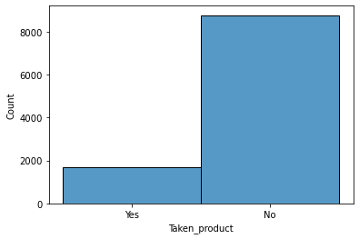
#Countplot for Taken product with other variables to compare the relation
ax = sns.countplot(x="Taken_product", hue="working_flag", data=data)
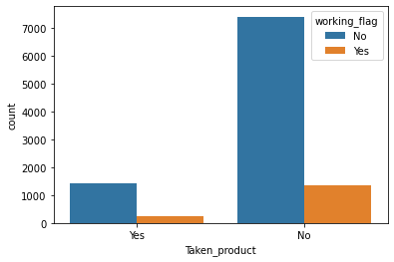
#Pref_device (Preferred device of the user through which user do login)
print(data.pref_device.value_counts())
print('\n---------------')
print('Proportion: \n',data.pref_device.value_counts(normalize=True))
Tab 4172
iOS and Android 3246
Laptop 1108
iOS 859
Mobile 600
Android 244
Android OS 126
ANDROID 97
Other 2
Others 1
Name: pref_device, dtype: int64
---------------
Proportion:
Tab 0.40
iOS and Android 0.31
Laptop 0.11
iOS 0.08
Mobile 0.06
Android 0.02
Android OS 0.01
ANDROID 0.01
Other 0.00
Others 0.00
Name: pref_device, dtype: float64
We can see there are so many devices mentioned in the dataset. But as per the information provided in the problem statement that 'Anything which is not a laptop can be considered as mobile phone usage', so we will replace everything with mobile except Laptop.
data['pref_device'].replace({'Tab': 'Mobile', 'iOS and Android': 'Mobile', 'iOS': 'Mobile',
'Android': 'Mobile', 'Android OS': 'Mobile', 'ANDROID': 'Mobile',
'iOS and Android': 'Mobile', 'Other': 'Mobile', 'Others': 'Mobile'}, inplace=True)
#Now again checking pref_device column
print(data.pref_device.value_counts())
print('\n---------------')
print('Proportion: \n',data.pref_device.value_counts(normalize=True))
Mobile 9347
Laptop 1108
Name: pref_device, dtype: int64
---------------
Proportion:
Mobile 0.89
Laptop 0.11
Name: pref_device, dtype: float64
This indicates that 89% of the people in our data use Mobile as their preferred device.
#Histogram for pref_device
sns.histplot(data=data, x="pref_device")
<AxesSubplot:xlabel='pref_device', ylabel='Count'>
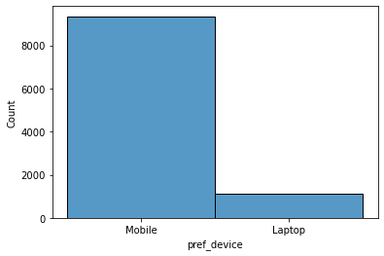
#Pref_loc_type (Preferred location type of the user)
print(data.pref_loc_type.value_counts())
Beach 2424
Financial 1875
Historical site 1856
Medical 1448
Big Cities 636
Other 581
Trekking 528
Social media 506
Entertainment 383
Hill Stations 108
Tour Travel 53
Tour and Travel 37
Game 10
OTT 6
Movie 4
Name: pref_loc_type, dtype: int64
We can see that there are various preferred location type available in the data. Let's assign few of them into one category and organize these.
- We will take Beach, Historical site, Trekking, Tour Travel, Tour and Travel and Hill Stations in one category and will name it 'Adventure and Tourism'.
- We will be replacing Game, OTT, Movie and Social Media with one already available category 'Entertainment'.
data['pref_loc_type'].replace({'Beach': 'Adventure and Tourism','Historical site': 'Adventure and Tourism',
'Trekking': 'Adventure and Tourism', 'Tour Travel': 'Adventure and Tourism',
'Tour and Travel': 'Adventure and Tourism', 'Hill Stations': 'Adventure and Tourism',
'Game': 'Entertainment', 'OTT': 'Entertainment', 'Movie': 'Entertainment',
'Social media': 'Entertainment'}, inplace=True)
#Checking the updated values and checking the proportion for each
print(data.pref_loc_type.value_counts())
print('\n---------------')
print('Proportion: \n',data.pref_loc_type.value_counts(normalize=True))
Adventure and Tourism 5006
Financial 1875
Medical 1448
Entertainment 909
Big Cities 636
Other 581
Name: pref_loc_type, dtype: int64
---------------
Proportion:
Adventure and Tourism 0.48
Financial 0.18
Medical 0.14
Entertainment 0.09
Big Cities 0.06
Other 0.06
Name: pref_loc_type, dtype: float64
So after organizing the categories, we found out that 'Adventure and Tourism' is the most preferred location type with 48%. Then 18% of the user has 'Financial' as their preferred location type, because they might travel mostly for business purpose. Then comes the 'Medical' as preferred location, as 14% of the user travel for their medical purposes. Only 9% of the users has 'Entertainment' as their preferred location type.
#Histogram for pref_loc_type
plt.xticks(rotation=90)
sns.histplot(data=data, x="pref_loc_type")
<AxesSubplot:xlabel='pref_loc_type', ylabel='Count'>
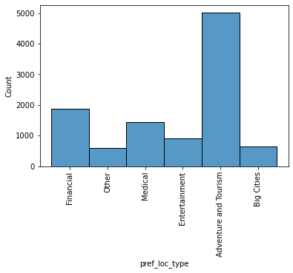
#Following_CP (whether the user is following the company page or not)
print(data.following_CP.value_counts())
No 7517
Yes 2923
1 10
0 5
Name: following_CP, dtype: int64
Here we need the data in the form of 'Yes' and 'No'. So we need to replace numeric value of 1 to Yes and 0 to No.
#replacing 1 and 0 with Yes and No respectively.
data['following_CP'].replace({'1': 'Yes', '0': 'No'}, inplace=True)
#Again checking
print(data.following_CP.value_counts())
print('\n---------------')
print('Proportion: \n',data.following_CP.value_counts(normalize = True))
No 7522
Yes 2933
Name: following_CP, dtype: int64
---------------
Proportion:
No 0.72
Yes 0.28
Name: following_CP, dtype: float64
We see that only 28% of the users are following the company page and 72% still do not follow.
#Histogram for following_CP
sns.histplot(data=data, x="following_CP")
<AxesSubplot:xlabel='following_CP', ylabel='Count'>
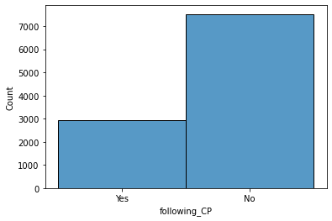
#Working_flag (whether the user is working somewhere or not)
print(data.working_flag.value_counts())
print('\n---------------')
print('Proportion: \n',data.working_flag.value_counts(normalize = True))
No 8846
Yes 1609
Name: working_flag, dtype: int64
---------------
Proportion:
No 0.85
Yes 0.15
Name: working_flag, dtype: float64
85% of the users do not work anywhere. Only 15% users are working.
#Histogram for working_flag
sns.histplot(data=data, x="working_flag")
<AxesSubplot:xlabel='working_flag', ylabel='Count'>
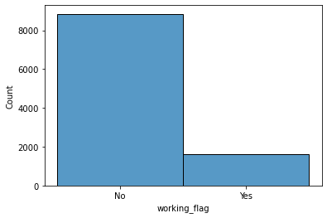
#members_in_fam (Number of members in the family of the user)
data.members_in_fam.value_counts()
3 4087
4 2843
2 1983
1 1192
5 331
10 10
Three 9
Name: members_in_fam, dtype: int64
Instead of numeric 3, it is in alphabet form, let's replace/correct it.
data['members_in_fam'].replace({'Three': '3'}, inplace=True)
data.members_in_fam.value_counts()
3 4096
4 2843
2 1983
1 1192
5 331
10 10
Name: members_in_fam, dtype: int64
Most of the users have 3 members in their family.
#Histogram for members_in_fam
sns.histplot(data=data, x="members_in_fam")
<AxesSubplot:xlabel='members_in_fam', ylabel='Count'>
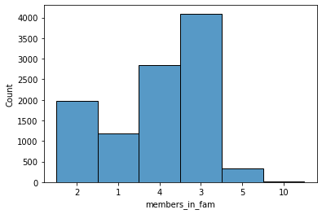
#Adult_flag (Whether the user is Adult or not)
#it should be either only 0 and 1, where 0 means user is not adult and 1 means user is adult.
data.Adult_flag.value_counts()
0 4476
1 4248
2 1114
3 617
Name: Adult_flag, dtype: int64
#here we will replace 2 and 3 with 1 because it's a categorical variable which must have only 2 options
#User can either be adult or not, so it should have values of either yes and no, or 1 and 0 and it can't be 2 and 3 in it .
data['Adult_flag'].replace({2: 1, 3: 1}, inplace=True)
#Now checking again
data.Adult_flag.value_counts()
1 5979
0 4476
Name: Adult_flag, dtype: int64
data.Adult_flag.value_counts(normalize=True)
1 0.57
0 0.43
Name: Adult_flag, dtype: float64
Around 57% users are adult.

Correcting the data types of few of the data columns :-
As we have checked that few variables indicating the incorrect data types like:
- 'YA_view_on_CP' should have integer type instead of float type.
- 'TL_done_on_OS_checkin' should have integer type instead of float type.
- 'YA_OS_checkin' should have integer type instead of object type.
- 'members_in_fam' should have integer type instead of object type.
- 'YA_comment_on_CP' should have integer type instead of float type.
data['YA_view_on_CP'] = data['YA_view_on_CP'].astype(np.int64)
data['TL_done_on_OS_checkin'] = data['TL_done_on_OS_checkin'].astype(np.int64)
data['YA_OS_checkin'] = data['YA_OS_checkin'].astype(np.int64)
data['members_in_fam'] = data['members_in_fam'].astype(np.int64)
data['YA_comment_on_CP'] = data['YA_comment_on_CP'].astype(np.int64)
#Let's check the dtypes again
data.dtypes
Taken_product object
YA_view_on_CP int64
pref_device object
TL_done_on_OS_checkin int64
YA_OS_checkin int64
members_in_fam int64
pref_loc_type object
YA_comment_on_CP int64
TL_rec_on_OS_checkin int64
week_since_last_OS_checkin int64
following_CP object
working_flag object
travelling_network_rating int64
Adult_flag int64
DA_mins_spend_on_CP int64
dtype: object

Detecting and Treating the Outliers :-
#Detecting Outliers by making a box plot for numerical attributes
sns.set(font_scale = 2)
data.boxplot(figsize=(25, 15), rot=90)
<AxesSubplot:>
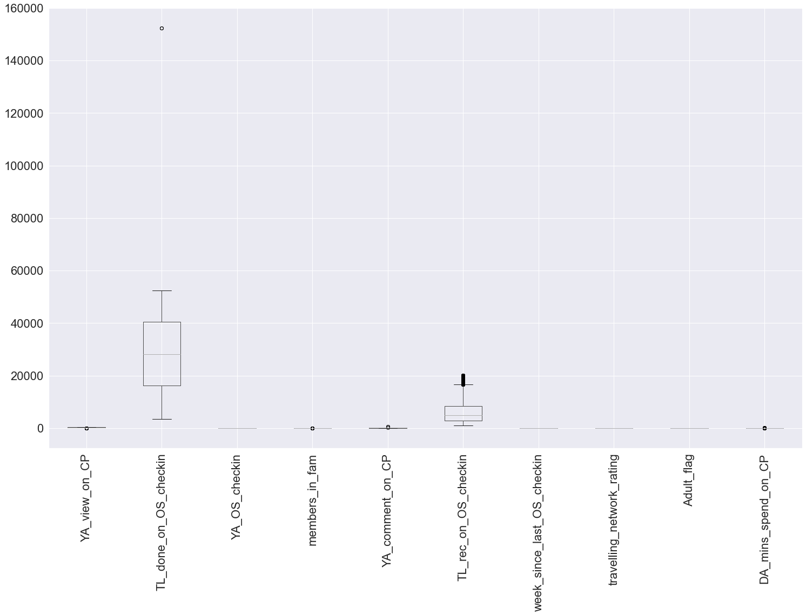
There are few outliers in the data.
#Let's look at them one by one for each numerical variables
num_columns = ['YA_view_on_CP' ,'TL_done_on_OS_checkin', 'YA_OS_checkin', 'members_in_fam', 'YA_comment_on_CP',
'TL_rec_on_OS_checkin','week_since_last_OS_checkin','travelling_network_rating','Adult_flag',
'DA_mins_spend_on_CP']
for col in num_columns:
plt.figure(figsize=(8,5))
sns.boxplot(data[col])
plt.show()
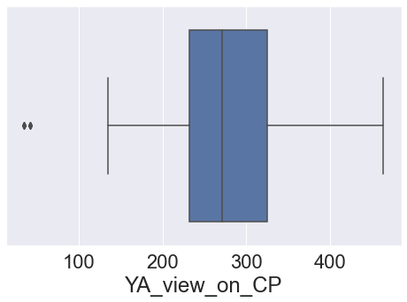
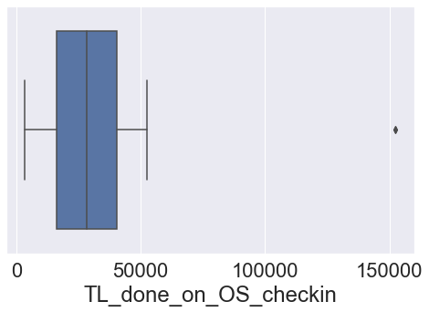
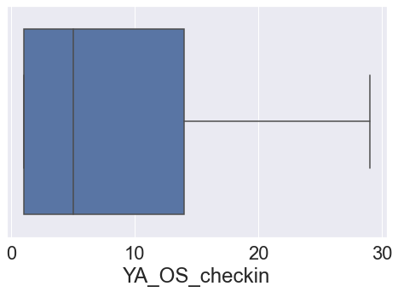
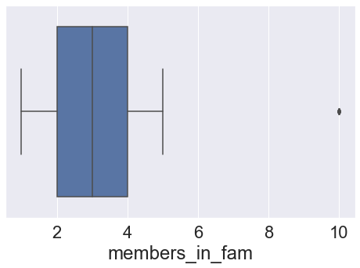
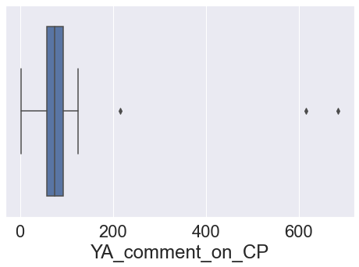
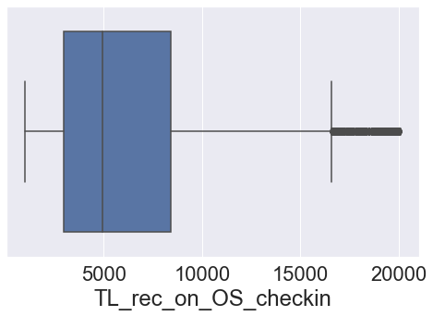
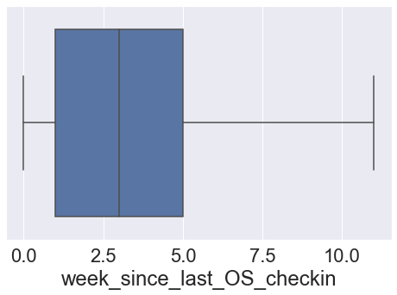
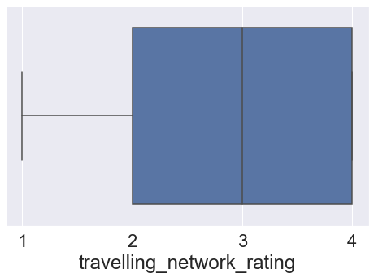
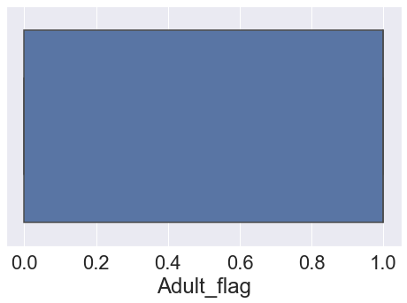
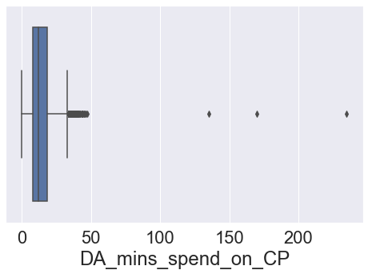

Treating Outliers :-
Treating the outliers by using Inter Quartile Range (IQR) method.This technique uses the IQR scores to remove outliers. The rule of thumb is that anything not in the range of (Q1 - 1.5 IQR) and (Q3 + 1.5 IQR) is an outlier, and can be removed.
#Calculating Q1 and Q3 values and assigning the upper limit (UL) and lower limit (LL)
Q1 = data[num_columns].quantile(0.25)
Q3 = data[num_columns].quantile(0.75)
IQR = Q3 - Q1
UL = Q3 + 1.5*IQR
LL = Q1 - 1.5*IQR
#Checking the number of outliers present in each column
pd.options.display.max_rows = None
((data[num_columns] > UL) | (data[num_columns] < LL)).sum()
YA_view_on_CP 8
TL_done_on_OS_checkin 2
YA_OS_checkin 0
members_in_fam 10
YA_comment_on_CP 3
TL_rec_on_OS_checkin 818
week_since_last_OS_checkin 0
travelling_network_rating 0
Adult_flag 0
DA_mins_spend_on_CP 315
dtype: int64
#Total sum of outliers
print('Total number of outliers in the dataset:',((data[num_columns] > UL) | (data[num_columns] < LL)).sum().sum())
Total number of outliers in the dataset: 1156
It is almost around 10%, we will remove those from our dataset
We will be defining a funtion named treat_outliers using that function we will remove those outliers.
def treat_outliers(col):
sorted(col)
Q1,Q3=np.percentile(col,[25,75])
IQR=Q3-Q1
lower_range= Q1-(1.5 * IQR)
upper_range= Q3+(1.5 * IQR)
return lower_range, upper_range
for column in data[num_columns].columns:
lr,ur=treat_outliers(data[column])
data[column]=np.where(data[column]>ur,ur,data[column])
data[column]=np.where(data[column]<lr,lr,data[column])
print('Lower Range:',lr)
print('Upper Range:',ur)
Lower Range: -7.0
Upper Range: 33.0
#Now checking again.
((data[num_columns] > UL) | (data[num_columns] < LL)).sum()
YA_view_on_CP 0
TL_done_on_OS_checkin 0
YA_OS_checkin 0
members_in_fam 0
YA_comment_on_CP 0
TL_rec_on_OS_checkin 0
week_since_last_OS_checkin 0
travelling_network_rating 0
Adult_flag 0
DA_mins_spend_on_CP 0
dtype: int64

Distribution Plot : For all numerical columns :-
for x in num_columns:
plt.figure(figsize=(10,8))
sns.displot(data[x], kde=True, color='green')
plt.show()
<Figure size 720x576 with 0 Axes>
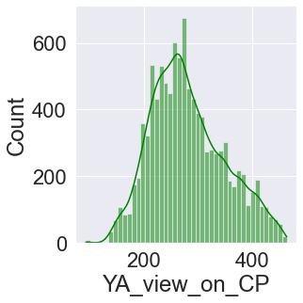
<Figure size 720x576 with 0 Axes>
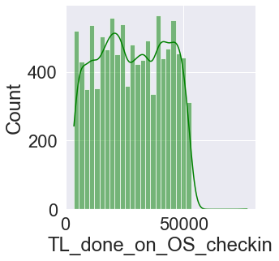
<Figure size 720x576 with 0 Axes>
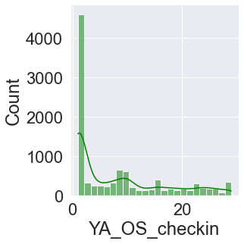
<Figure size 720x576 with 0 Axes>
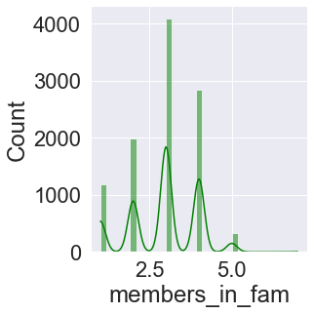
<Figure size 720x576 with 0 Axes>
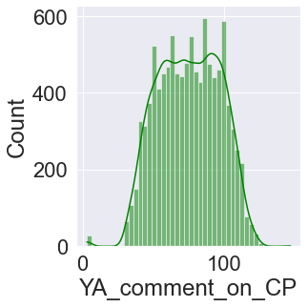
<Figure size 720x576 with 0 Axes>
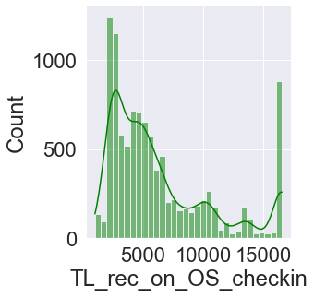
<Figure size 720x576 with 0 Axes>
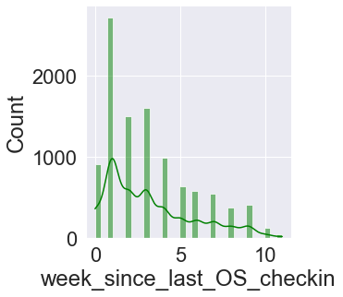
<Figure size 720x576 with 0 Axes>
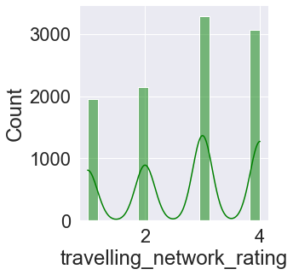
<Figure size 720x576 with 0 Axes>
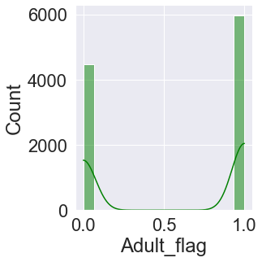
<Figure size 720x576 with 0 Axes>
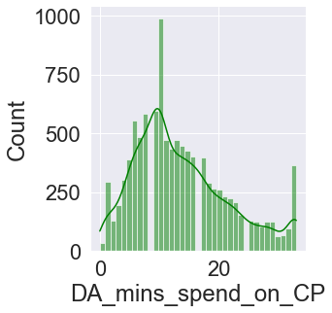

Bivariate Analysis :-

Correlation Matrix :-
#Now let see the correlation between the variables using correlation matrics
corr = data.corr()
corr
YA_view_on_CP TL_done_on_OS_checkin \
YA_view_on_CP 1.00 0.01
TL_done_on_OS_checkin 0.01 1.00
YA_OS_checkin 0.01 0.00
members_in_fam 0.20 -0.01
YA_comment_on_CP 0.04 0.01
TL_rec_on_OS_checkin 0.50 0.01
week_since_last_OS_checkin 0.29 0.04
travelling_network_rating 0.05 0.00
Adult_flag 0.09 0.03
DA_mins_spend_on_CP 0.64 0.02
YA_OS_checkin members_in_fam YA_comment_on_CP \
YA_view_on_CP 0.01 0.20 0.04
TL_done_on_OS_checkin 0.00 -0.01 0.01
YA_OS_checkin 1.00 0.02 0.06
members_in_fam 0.02 1.00 0.01
YA_comment_on_CP 0.06 0.01 1.00
TL_rec_on_OS_checkin -0.00 0.10 -0.01
week_since_last_OS_checkin -0.03 0.11 0.06
travelling_network_rating 0.01 -0.01 0.00
Adult_flag 0.04 0.01 0.04
DA_mins_spend_on_CP 0.01 0.13 0.07
TL_rec_on_OS_checkin week_since_last_OS_checkin \
YA_view_on_CP 0.50 0.29
TL_done_on_OS_checkin 0.01 0.04
YA_OS_checkin -0.00 -0.03
members_in_fam 0.10 0.11
YA_comment_on_CP -0.01 0.06
TL_rec_on_OS_checkin 1.00 0.15
week_since_last_OS_checkin 0.15 1.00
travelling_network_rating 0.02 0.05
Adult_flag 0.06 0.02
DA_mins_spend_on_CP 0.72 0.28
travelling_network_rating Adult_flag \
YA_view_on_CP 0.05 0.09
TL_done_on_OS_checkin 0.00 0.03
YA_OS_checkin 0.01 0.04
members_in_fam -0.01 0.01
YA_comment_on_CP 0.00 0.04
TL_rec_on_OS_checkin 0.02 0.06
week_since_last_OS_checkin 0.05 0.02
travelling_network_rating 1.00 -0.06
Adult_flag -0.06 1.00
DA_mins_spend_on_CP 0.02 0.07
DA_mins_spend_on_CP
YA_view_on_CP 0.64
TL_done_on_OS_checkin 0.02
YA_OS_checkin 0.01
members_in_fam 0.13
YA_comment_on_CP 0.07
TL_rec_on_OS_checkin 0.72
week_since_last_OS_checkin 0.28
travelling_network_rating 0.02
Adult_flag 0.07
DA_mins_spend_on_CP 1.00

Heatmap :-
#Now we will plot the heatmap to display the correlation between the variables:
sns.set(font_scale=1.2)
fig, ax = plt.subplots(figsize=(13,10))
sns.heatmap(corr,annot=True)
<AxesSubplot:>
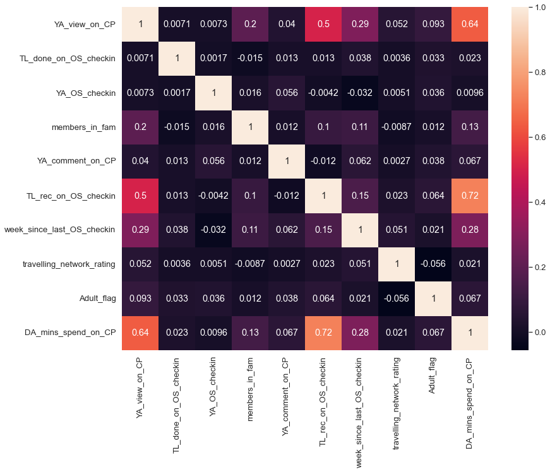

So here in the above heatmap we can see that the light colours shows the highest correlation between 2 variables.

Highest correlated variables are :-
- 'TL_rec_on_OS_checkin' and 'DA_mins_spend_on_CP' (0.72)
- 'YA_view_on_CP' and 'DA_mins_spend_on_CP' (0.64)
- 'TL_rec_on_OS_checkin' and 'YA_view_on_CP' (0.5)

PairPlot :-
sns.set(font_scale=1.2)
sns.pairplot(data)
<seaborn.axisgrid.PairGrid at 0x23646cc4550>
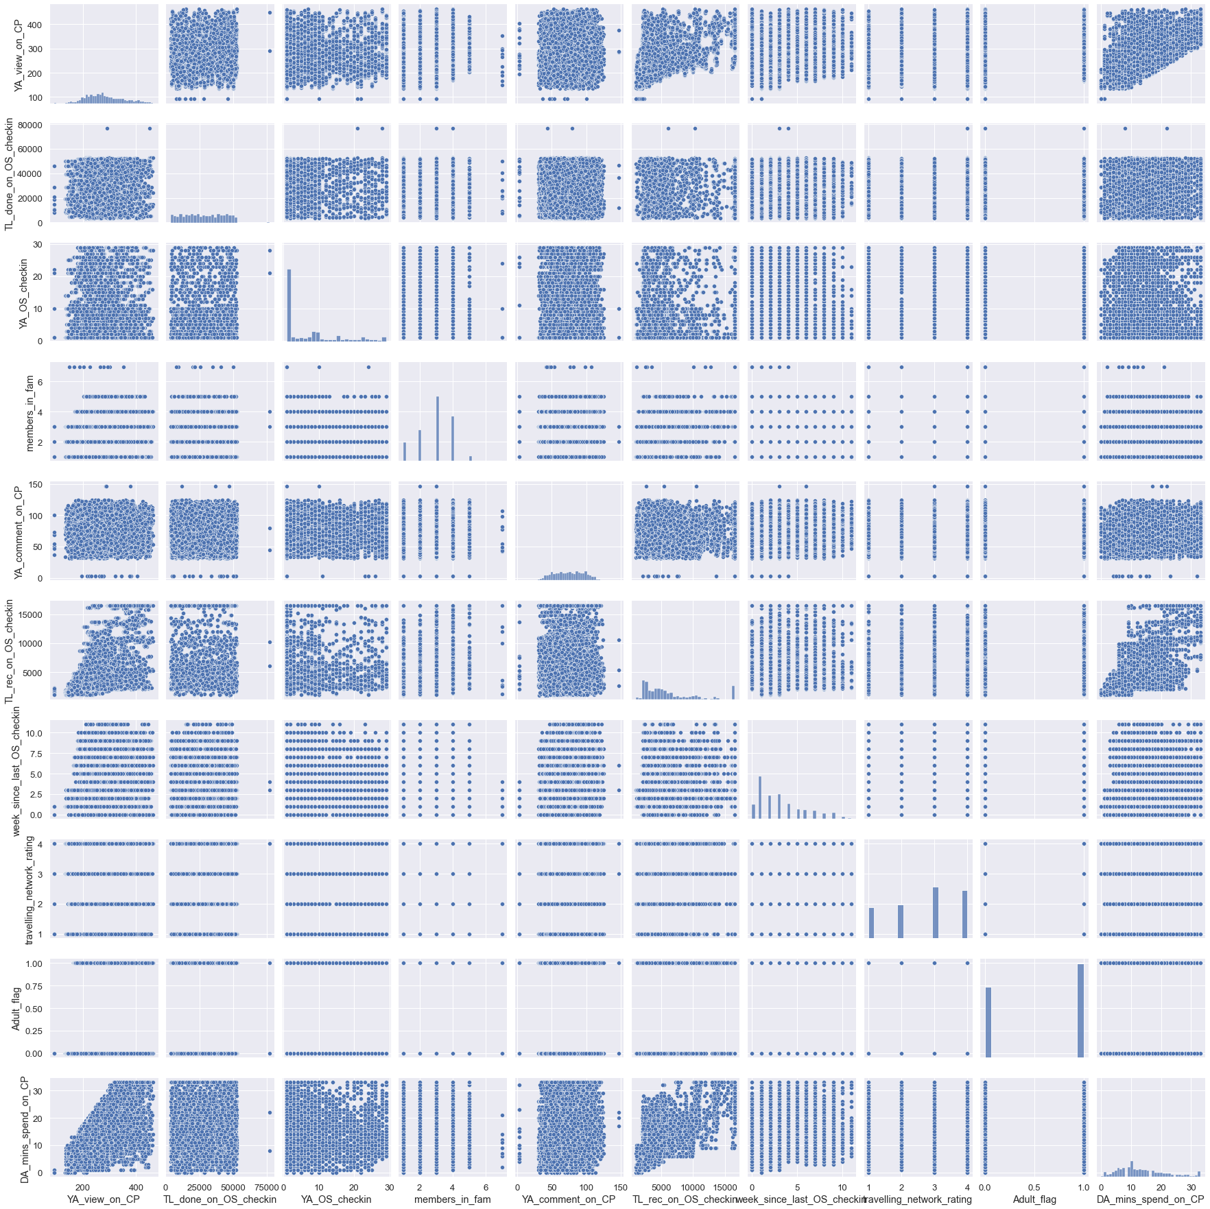
_________________________________________END__________________________________________

Capstone Project: Project Notes - 2
The second set of project notes must include the model building aspect and be aligned to the analytical business problem the Capstone Project addresses. It should also include the rationale behind using/building one particular model (if applicable). The notes should be brief and succinct containing the depiction of the results for the models built aligned with the objective of the project.

1. Model building and interpretation.
- Build various models (You can choose to build models for either or all of descriptive, predictive or prescriptive purposes).
- Test your predictive model against the test set using various appropriate performance metrics c.Interpretation of the model(s).

Importing the required libraries :-
from sklearn.preprocessing import MinMaxScaler
from sklearn.preprocessing import StandardScaler
from sklearn.model_selection import train_test_split
from sklearn.linear_model import LogisticRegression
from sklearn.metrics import confusion_matrix, classification_report
from imblearn.over_sampling import SMOTE
from sklearn.model_selection import GridSearchCV
from sklearn import metrics
from sklearn.metrics import roc_auc_score,roc_curve,classification_report,confusion_matrix,plot_confusion_matrix
from sklearn.neighbors import KNeighborsClassifier
from sklearn.ensemble import GradientBoostingClassifier
from sklearn.ensemble import AdaBoostClassifier
from sklearn.ensemble import BaggingClassifier
from sklearn.ensemble import RandomForestClassifier
from sklearn.naive_bayes import GaussianNB
data.head().T
0 1 2 3 4
Taken_product Yes No Yes No No
YA_view_on_CP 307.00 367.00 277.00 247.00 202.00
pref_device Mobile Mobile Mobile Mobile Mobile
TL_done_on_OS_checkin 38570.00 9765.00 48055.00 48720.00 20685.00
YA_OS_checkin 1.00 1.00 1.00 1.00 1.00
members_in_fam 2.00 1.00 2.00 4.00 1.00
pref_loc_type Financial Financial Other Financial Medical
YA_comment_on_CP 94.00 61.00 92.00 56.00 40.00
TL_rec_on_OS_checkin 5993.00 5130.00 2090.00 2909.00 3468.00
week_since_last_OS_checkin 8.00 1.00 6.00 1.00 9.00
following_CP Yes No Yes Yes No
working_flag No Yes No No No
travelling_network_rating 1.00 4.00 2.00 3.00 4.00
Adult_flag 0.00 1.00 0.00 0.00 1.00
DA_mins_spend_on_CP 8.00 10.00 7.00 8.00 6.00
data.info()
<class 'pandas.core.frame.DataFrame'>
Int64Index: 10455 entries, 0 to 11759
Data columns (total 15 columns):
# Column Non-Null Count Dtype
--- ------ -------------- -----
0 Taken_product 10455 non-null object
1 YA_view_on_CP 10455 non-null float64
2 pref_device 10455 non-null object
3 TL_done_on_OS_checkin 10455 non-null float64
4 YA_OS_checkin 10455 non-null float64
5 members_in_fam 10455 non-null float64
6 pref_loc_type 10455 non-null object
7 YA_comment_on_CP 10455 non-null float64
8 TL_rec_on_OS_checkin 10455 non-null float64
9 week_since_last_OS_checkin 10455 non-null float64
10 following_CP 10455 non-null object
11 working_flag 10455 non-null object
12 travelling_network_rating 10455 non-null float64
13 Adult_flag 10455 non-null float64
14 DA_mins_spend_on_CP 10455 non-null float64
dtypes: float64(10), object(5)
memory usage: 1.5+ MB

We have to build models separately for Laptop and Mobile users : Let's make 2 different dataframes for each :-
So, let us first split the dataset into two seperate dataframes.
# data_laptop is the dataset of the users who preferred laptop
data_laptop = data[data['pref_device'] == 'Laptop']
# data_mobile is the dataset of the users who preferred mobile
data_mobile = data[data['pref_device'] == 'Mobile']
print('Shape of the dataset:',data_laptop.shape)
data_laptop.head().T
Shape of the dataset: (1108, 15)
5881 5883 \
Taken_product No No
YA_view_on_CP 379.00 255.00
pref_device Laptop Laptop
TL_done_on_OS_checkin 9776.00 48725.00
YA_OS_checkin 8.00 3.00
members_in_fam 1.00 4.00
pref_loc_type Adventure and Tourism Adventure and Tourism
YA_comment_on_CP 64.00 59.00
TL_rec_on_OS_checkin 5142.00 2913.00
week_since_last_OS_checkin 1.00 1.00
following_CP No Yes
working_flag Yes No
travelling_network_rating 4.00 3.00
Adult_flag 1.00 0.00
DA_mins_spend_on_CP 10.00 8.00
5885 5888 \
Taken_product No No
YA_view_on_CP 250.00 295.00
pref_device Laptop Laptop
TL_done_on_OS_checkin 35184.00 7572.00
YA_OS_checkin 2.00 23.00
members_in_fam 2.00 3.00
pref_loc_type Adventure and Tourism Adventure and Tourism
YA_comment_on_CP 84.00 48.00
TL_rec_on_OS_checkin 3074.00 9532.00
week_since_last_OS_checkin 0.00 0.00
following_CP No No
working_flag No Yes
travelling_network_rating 3.00 2.00
Adult_flag 0.00 0.00
DA_mins_spend_on_CP 8.00 10.00
5906
Taken_product Yes
YA_view_on_CP 250.00
pref_device Laptop
TL_done_on_OS_checkin 39379.00
YA_OS_checkin 16.00
members_in_fam 1.00
pref_loc_type Adventure and Tourism
YA_comment_on_CP 80.00
TL_rec_on_OS_checkin 3926.00
week_since_last_OS_checkin 1.00
following_CP Yes
working_flag Yes
travelling_network_rating 2.00
Adult_flag 0.00
DA_mins_spend_on_CP 10.00
data_laptop.describe().T
count mean std min 25% \
YA_view_on_CP 1108.00 282.13 64.24 138.00 237.00
TL_done_on_OS_checkin 1108.00 27769.66 13361.84 3818.00 17650.25
YA_OS_checkin 1108.00 9.28 8.41 1.00 2.00
members_in_fam 1108.00 2.90 1.04 1.00 2.00
YA_comment_on_CP 1108.00 77.50 21.04 33.00 60.00
TL_rec_on_OS_checkin 1108.00 6130.68 4105.79 1098.00 2884.00
week_since_last_OS_checkin 1108.00 3.00 2.49 0.00 1.00
travelling_network_rating 1108.00 2.78 1.08 1.00 2.00
Adult_flag 1108.00 0.56 0.50 0.00 0.00
DA_mins_spend_on_CP 1108.00 13.54 7.93 0.00 8.00
50% 75% max
YA_view_on_CP 270.50 325.00 463.00
TL_done_on_OS_checkin 26942.50 39380.25 52512.00
YA_OS_checkin 7.00 15.00 29.00
members_in_fam 3.00 4.00 5.00
YA_comment_on_CP 77.00 95.00 125.00
TL_rec_on_OS_checkin 4759.50 7979.50 16572.00
week_since_last_OS_checkin 2.00 4.00 11.00
travelling_network_rating 3.00 4.00 4.00
Adult_flag 1.00 1.00 1.00
DA_mins_spend_on_CP 11.50 18.00 33.00
print('Shape of the dataset:',data_mobile.shape)
data_mobile.head().T
Shape of the dataset: (9347, 15)
0 1 2 3 4
Taken_product Yes No Yes No No
YA_view_on_CP 307.00 367.00 277.00 247.00 202.00
pref_device Mobile Mobile Mobile Mobile Mobile
TL_done_on_OS_checkin 38570.00 9765.00 48055.00 48720.00 20685.00
YA_OS_checkin 1.00 1.00 1.00 1.00 1.00
members_in_fam 2.00 1.00 2.00 4.00 1.00
pref_loc_type Financial Financial Other Financial Medical
YA_comment_on_CP 94.00 61.00 92.00 56.00 40.00
TL_rec_on_OS_checkin 5993.00 5130.00 2090.00 2909.00 3468.00
week_since_last_OS_checkin 8.00 1.00 6.00 1.00 9.00
following_CP Yes No Yes Yes No
working_flag No Yes No No No
travelling_network_rating 1.00 4.00 2.00 3.00 4.00
Adult_flag 0.00 1.00 0.00 0.00 1.00
DA_mins_spend_on_CP 8.00 10.00 7.00 8.00 6.00
data_mobile.describe().T
count mean std min 25% \
YA_view_on_CP 9347.00 281.21 68.60 92.50 232.00
TL_done_on_OS_checkin 9347.00 28186.09 14215.68 3570.00 16240.00
YA_OS_checkin 9347.00 8.17 8.58 1.00 1.00
members_in_fam 9347.00 2.92 1.02 1.00 2.00
YA_comment_on_CP 9347.00 74.76 21.85 3.00 57.00
TL_rec_on_OS_checkin 9347.00 6421.30 4368.67 1009.00 2960.50
week_since_last_OS_checkin 9347.00 3.23 2.63 0.00 1.00
travelling_network_rating 9347.00 2.71 1.08 1.00 2.00
Adult_flag 9347.00 0.57 0.49 0.00 0.00
DA_mins_spend_on_CP 9347.00 13.69 7.99 0.00 8.00
50% 75% max
YA_view_on_CP 271.00 325.00 464.00
TL_done_on_OS_checkin 28294.00 40672.00 76843.25
YA_OS_checkin 4.00 14.00 29.00
members_in_fam 3.00 4.00 7.00
YA_comment_on_CP 75.00 93.00 147.00
TL_rec_on_OS_checkin 4968.00 8398.50 16572.00
week_since_last_OS_checkin 3.00 5.00 11.00
travelling_network_rating 3.00 4.00 4.00
Adult_flag 1.00 1.00 1.00
DA_mins_spend_on_CP 12.00 18.00 33.00

Data Encoding for Modeling Purpose : Now, we will do 'One Hot Encoding' for the object type variables :-
data_laptop_dummy = pd.get_dummies(data_laptop, drop_first=True)
data_laptop_dummy.head().T
5881 5883 5885 5888 5906
YA_view_on_CP 379.00 255.00 250.00 295.00 250.00
TL_done_on_OS_checkin 9776.00 48725.00 35184.00 7572.00 39379.00
YA_OS_checkin 8.00 3.00 2.00 23.00 16.00
members_in_fam 1.00 4.00 2.00 3.00 1.00
YA_comment_on_CP 64.00 59.00 84.00 48.00 80.00
TL_rec_on_OS_checkin 5142.00 2913.00 3074.00 9532.00 3926.00
week_since_last_OS_checkin 1.00 1.00 0.00 0.00 1.00
travelling_network_rating 4.00 3.00 3.00 2.00 2.00
Adult_flag 1.00 0.00 0.00 0.00 0.00
DA_mins_spend_on_CP 10.00 8.00 8.00 10.00 10.00
Taken_product_Yes 0.00 0.00 0.00 0.00 1.00
pref_loc_type_Big Cities 0.00 0.00 0.00 0.00 0.00
pref_loc_type_Other 0.00 0.00 0.00 0.00 0.00
following_CP_Yes 0.00 1.00 0.00 0.00 1.00
working_flag_Yes 1.00 0.00 0.00 1.00 1.00
data_mobile_dummy = pd.get_dummies(data_mobile, drop_first=True)
data_mobile_dummy.head().T
0 1 2 3 4
YA_view_on_CP 307.00 367.00 277.00 247.00 202.00
TL_done_on_OS_checkin 38570.00 9765.00 48055.00 48720.00 20685.00
YA_OS_checkin 1.00 1.00 1.00 1.00 1.00
members_in_fam 2.00 1.00 2.00 4.00 1.00
YA_comment_on_CP 94.00 61.00 92.00 56.00 40.00
TL_rec_on_OS_checkin 5993.00 5130.00 2090.00 2909.00 3468.00
week_since_last_OS_checkin 8.00 1.00 6.00 1.00 9.00
travelling_network_rating 1.00 4.00 2.00 3.00 4.00
Adult_flag 0.00 1.00 0.00 0.00 1.00
DA_mins_spend_on_CP 8.00 10.00 7.00 8.00 6.00
Taken_product_Yes 1.00 0.00 1.00 0.00 0.00
pref_loc_type_Big Cities 0.00 0.00 0.00 0.00 0.00
pref_loc_type_Entertainment 0.00 0.00 0.00 0.00 0.00
pref_loc_type_Financial 1.00 1.00 0.00 1.00 0.00
pref_loc_type_Medical 0.00 0.00 0.00 0.00 1.00
pref_loc_type_Other 0.00 0.00 1.00 0.00 0.00
following_CP_Yes 1.00 0.00 1.00 1.00 0.00
working_flag_Yes 0.00 1.00 0.00 0.00 0.00

Calculations for Model Building : For Laptop Users

Train-Test Split :-
#Now, let's separate dependent and independent variables
X = data_laptop_dummy.drop('Taken_product_Yes', axis=1)
Y = data_laptop_dummy[['Taken_product_Yes']]
# Split the data into test and train sets in 70:30 ratio
X_train, X_test, Y_train, Y_test = train_test_split(X, Y, test_size = 0.30, random_state = 11)
print("{0:0.2f}% data is in training set".format((len(X_train)/len(data_laptop_dummy.index)) * 100))
print("{0:0.2f}% data is in test set".format((len(X_test)/len(data_laptop_dummy.index)) * 100))
69.95% data is in training set
30.05% data is in test set
print('Shape of X_train:',X_train.shape)
X_train.head().T
Shape of X_train: (775, 14)
9580 8684 6956 11043 9186
YA_view_on_CP 409.00 214.00 408.00 307.00 321.00
TL_done_on_OS_checkin 4393.00 39588.00 36753.00 33122.00 5040.00
YA_OS_checkin 2.00 15.00 11.00 22.00 4.00
members_in_fam 3.00 3.00 4.00 3.00 3.00
YA_comment_on_CP 54.00 80.00 90.00 108.00 73.00
TL_rec_on_OS_checkin 7586.00 4785.00 16038.00 10930.00 9418.00
week_since_last_OS_checkin 2.00 0.00 3.00 1.00 1.00
travelling_network_rating 1.00 4.00 1.00 3.00 3.00
Adult_flag 1.00 1.00 1.00 0.00 0.00
DA_mins_spend_on_CP 33.00 8.00 26.00 23.00 10.00
pref_loc_type_Big Cities 1.00 0.00 0.00 0.00 1.00
pref_loc_type_Other 0.00 0.00 0.00 0.00 0.00
following_CP_Yes 0.00 0.00 0.00 1.00 0.00
working_flag_Yes 0.00 0.00 1.00 0.00 0.00
# Normalization of X_train
normalized_X_train = pd.DataFrame(StandardScaler().fit_transform(X_train),columns = X_train.columns)
print('Shape of y_train:',Y_train.shape)
Y_train.head().T
Shape of y_train: (775, 1)
9580 8684 6956 11043 9186
Taken_product_Yes 0 0 0 0 1
print('Shape of X_test:',X_test.shape)
X_test.head().T
Shape of X_test: (333, 14)
9905 6087 7577 9102 7807
YA_view_on_CP 238.00 280.00 226.00 227.00 143.00
TL_done_on_OS_checkin 19691.00 22230.00 49466.00 15525.00 45722.00
YA_OS_checkin 3.00 18.00 1.00 2.00 5.00
members_in_fam 3.00 1.00 1.00 2.00 3.00
YA_comment_on_CP 50.00 76.00 51.00 61.00 73.00
TL_rec_on_OS_checkin 4147.00 2164.00 7929.00 4620.00 1885.00
week_since_last_OS_checkin 1.00 1.00 1.00 1.00 1.00
travelling_network_rating 1.00 1.00 4.00 1.00 4.00
Adult_flag 0.00 0.00 1.00 0.00 0.00
DA_mins_spend_on_CP 12.00 8.00 11.00 17.00 0.00
pref_loc_type_Big Cities 0.00 0.00 0.00 0.00 1.00
pref_loc_type_Other 0.00 0.00 0.00 0.00 0.00
following_CP_Yes 0.00 0.00 0.00 0.00 1.00
working_flag_Yes 0.00 0.00 0.00 0.00 0.00
# Normalization of X_test
normalized_X_test = pd.DataFrame(StandardScaler().fit_transform(X_test),columns = X_test.columns)
print('Shape of y_test:',Y_test.shape)
Y_test.head()
Shape of y_test: (333, 1)
Taken_product_Yes
9905 1
6087 0
7577 0
9102 0
7807 1
data_laptop_dummy['Taken_product_Yes'].value_counts()
0 832
1 276
Name: Taken_product_Yes, dtype: int64
832 laptop users has not taken the product and only 276 users has taken the product. This means that there is class imbalance in the dataset, where 1 is minority class and 0 is in majority class.

Need of applying SMOTE :-
As per our analysis, we got to know that the data is more towards the negative side, like majority of the users have not taken our product.This clearly means that data is in imbalance state.
Standard ML techniques such as Decision Tree and Logistic Regression have a bias towards the majority class, and they tend to ignore the minority class. They tend only to predict the majority class, hence, having major misclassification of the minority class in comparison with the majority class. In more technical words, if we have imbalanced data distribution in our dataset then our model becomes more prone to the case when minority class has negligible or very lesser recall.
So we will be using a over sampling technique called SMOTE to handle imbalanced data.

Logistic Regression Model (with default values) : On imbalance data
LR = LogisticRegression()
# Now let's fit the model on training data
LR.fit(normalized_X_train, Y_train)
LogisticRegression()
# Prdecition on training data
Y_train_predict = LR.predict(normalized_X_train)
# Prdecition on testing data
Y_test_predict = LR.predict(normalized_X_test)
# Getting the predicted classes and probs
Y_test_predict_prob = LR.predict_proba(normalized_X_test)
# Model Evaluation - Accuracy on training data
LR.score(normalized_X_train, Y_train)
0.8490322580645161
# Classification Report - training data
print(classification_report(Y_train, Y_train_predict))
precision recall f1-score support
0 0.86 0.95 0.91 588
1 0.78 0.52 0.62 187
accuracy 0.85 775
macro avg 0.82 0.74 0.76 775
weighted avg 0.84 0.85 0.84 775
# Classification Report - testing data
print(classification_report(Y_test, Y_test_predict))
precision recall f1-score support
0 0.80 0.93 0.86 244
1 0.67 0.38 0.49 89
accuracy 0.78 333
macro avg 0.74 0.66 0.67 333
weighted avg 0.77 0.78 0.76 333
We can clearly see that the accuracy comes out to be 78% in test data and 85% in train data, but, the recall of the minority class in very less(38%). It means that the model is more biased towards majority class. So, it proves that this is not the best model, and it might be because of class imbalance.

Applying SMOTE :-
Now, we will apply the imbalanced data handling technique, called SMOTE and see their accuracy and recall results.
SM = SMOTE(random_state = 2)
X_train_SM, Y_train_SM = SM.fit_sample(normalized_X_train, Y_train)
print('After OverSampling, the shape of X_train:',X_train_SM.shape)
print('After OverSampling, the shape of Y_train:',Y_train_SM.shape)
After OverSampling, the shape of X_train: (1176, 14)
After OverSampling, the shape of Y_train: (1176, 1)

Logistic Regression Model (with default values) : On balanced data - After applying SMOTE - Oversampling
Now we will again make the model again and check the recall values for majority and minority classes
LR_SM = LogisticRegression()
# Now let's fit the model on train data
LR_SM.fit(X_train_SM, Y_train_SM)
LogisticRegression()
# Prdecition on training data
Y_train_predict_SM = LR_SM.predict(X_train_SM)
# Prdecition on testing data
Y_test_predict_SM = LR_SM.predict(normalized_X_test)
# Model Evaluation - Accuracy on training data
LR_SM.score(X_train_SM, Y_train_SM)
0.7874149659863946
# Classification Report - training data
print(classification_report(Y_train_SM, Y_train_predict_SM))
precision recall f1-score support
0 0.80 0.77 0.78 588
1 0.78 0.80 0.79 588
accuracy 0.79 1176
macro avg 0.79 0.79 0.79 1176
weighted avg 0.79 0.79 0.79 1176
# Classification Report - testing data
print(classification_report(Y_test, Y_test_predict_SM))
precision recall f1-score support
0 0.87 0.75 0.80 244
1 0.50 0.70 0.58 89
accuracy 0.73 333
macro avg 0.69 0.72 0.69 333
weighted avg 0.77 0.73 0.74 333
Now the difference is clear, that after over-sampling, the accuracy has been decreased from 85% to 73%.
But as we know that the accuracy is not the good predictor here in our case because we are dealing with less classes and it is also a classification algorithm.
So here we will focus more on improving our recall. Now, the recall for the minority class has been increased a lot, and it is 70%. That is very good. But the recall for the majority class has been decreased, this is due the fact that now that there is a balance in both the classes.
Recall value for the minority class(1) is 0.70 which is a good prediction, since our model has predicted 70% of the 1's as 1's and only 30% of the prediction were wrong.

Logistic Regression Model (Customized Values) : On balanced data - After applying SMOTE - Oversampling
As we have built the previous model with it's default values. There might be chances of better model than this, with some customized parameters for the logistic regression model.
We can improve the model by tuning the hyper-parameters of the model. So here we will use some custom parameters and then check our model performance.
# Fit the Logistic Regression model
LR_SM_custom = LogisticRegression(solver='lbfgs', penalty='none', max_iter=100000, n_jobs=2, verbose=True)
LR_SM_custom.fit(X_train_SM, Y_train_SM)
[Parallel(n_jobs=2)]: Using backend LokyBackend with 2 concurrent workers.
[Parallel(n_jobs=2)]: Done 1 out of 1 | elapsed: 1.8s finished
LogisticRegression(max_iter=100000, n_jobs=2, penalty='none', verbose=True)
# Prdecition on training data
Y_train_predict_SM_custom = LR_SM_custom.predict(X_train_SM)
# Prdecition on testing data
Y_test_predict_SM_custom = LR_SM_custom.predict(normalized_X_test)
# Model Evaluation - Accuracy on training data
LR_SM_custom.score(X_train_SM, Y_train_SM)
0.7882653061224489
# Classification Report - training data
print(classification_report(Y_train_SM, Y_train_predict_SM_custom))
precision recall f1-score support
0 0.80 0.77 0.79 588
1 0.78 0.80 0.79 588
accuracy 0.79 1176
macro avg 0.79 0.79 0.79 1176
weighted avg 0.79 0.79 0.79 1176
# Classification Report - testing data
print(classification_report(Y_test, Y_test_predict_SM_custom))
precision recall f1-score support
0 0.87 0.75 0.80 244
1 0.50 0.70 0.58 89
accuracy 0.73 333
macro avg 0.69 0.72 0.69 333
weighted avg 0.77 0.73 0.74 333
There is not much difference in the matrix using customized parameters.

Confusion Matrix, AUC, ROC for the Model :-
# Confusion matrix on the training data
plot_confusion_matrix(LR_SM, X_train_SM, Y_train_SM)
<sklearn.metrics._plot.confusion_matrix.ConfusionMatrixDisplay at 0x2364ee34610>
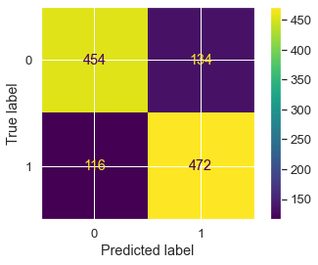
So, True Positives are coming here is 472, that means 472 times our model has predicted correctly, that means it has predicted 1 as 1, and only 116 times it has predicted incorrectly.
Similarly, True Negatives are 454 that means 454 times it has predicted 0 as 0 and only 116 times, the prediction was incorrect.
# Confusion Matrix - Test data
plot_confusion_matrix(LR_SM, normalized_X_test, Y_test)
<sklearn.metrics._plot.confusion_matrix.ConfusionMatrixDisplay at 0x2364ee73130>
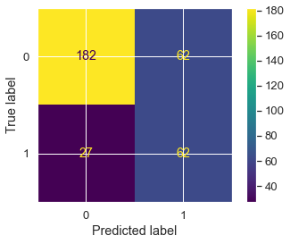
So, in test data, True Positives are coming here is 62, that means 62 times our model has predicted correctly, that means it has predicted 1 as 1, and only 27 times it has predicted incorrectly.
Similarly, True Negatives are 182 that means 182 times it has predicted 0 as 0 and only 62 times, the prediction was incorrect.
# Predicting Probabilities
probs = LR_SM.predict_proba(X_train_SM)
# keep probabilities for the positive outcome only
probs = probs[:, 1]
# Calculate Area Under Curve
auc = roc_auc_score(Y_train_SM, probs)
print('AUC: %.3f' % auc)
AUC: 0.862
# Calculate ROC curve
train_fpr, train_tpr, train_thresholds = roc_curve(Y_train_SM, probs)
plt.rcParams["figure.figsize"] = (8,6)
plt.plot([0, 1], [0, 1], linestyle='--')
# plot the roc curve for the model
plt.plot(train_fpr, train_tpr);
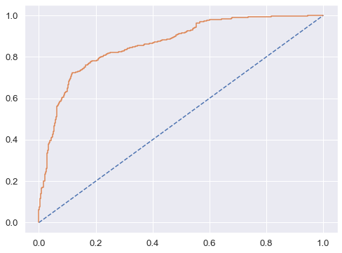
#Accuracy score - for Test data
acc_test = LR_SM.score(normalized_X_test, Y_test)
acc_test
0.7327327327327328
So in the above model, the area under the curve is 86% that means the overall model performance is good.
Also, the confusion matrix and classification report the LR_SM Logistic Regression Model is giving the good results.

Using GridSearchCV for Logistic Regression :-
grid = {'penalty':['l2','none'], 'solver':['sag','lbfgs'], 'tol':[0.0001,0.00001]}
LR_grid = LogisticRegression(max_iter=10000, n_jobs=2)
grid_search = GridSearchCV(estimator=LR_grid, param_grid = grid, cv=3, n_jobs=-1, scoring='f1')
grid_search.fit(X_train_SM, Y_train_SM)
GridSearchCV(cv=3, estimator=LogisticRegression(max_iter=10000, n_jobs=2),
n_jobs=-1,
param_grid={'penalty': ['l2', 'none'], 'solver': ['sag', 'lbfgs'],
'tol': [0.0001, 1e-05]},
scoring='f1')
print('Best Parameters from GridSearch:',grid_search.best_params_)
print('\nBest estimator from GridSearch:',grid_search.best_estimator_)
Best Parameters from GridSearch: {'penalty': 'l2', 'solver': 'sag', 'tol': 0.0001}
Best estimator from GridSearch: LogisticRegression(max_iter=10000, n_jobs=2, solver='sag')
best_LR_model = grid_search.best_estimator_
# Prediction - on Train data
Y_train_grid_predict = best_LR_model.predict(X_train_SM)
Y_test_grid_predict = best_LR_model.predict(normalized_X_test)
# Predicting Probabilities - on Test data
Y_test_grid_predict_prob = best_LR_model.predict_proba(normalized_X_test)
pd.DataFrame(Y_test_grid_predict_prob).head()
0 1
0 0.60 0.40
1 0.23 0.77
2 0.99 0.01
3 0.67 0.33
4 0.21 0.79
# Confusion Matrix - Train data
plot_confusion_matrix(best_LR_model, X_train_SM, Y_train_SM)
<sklearn.metrics._plot.confusion_matrix.ConfusionMatrixDisplay at 0x2364c8a79a0>
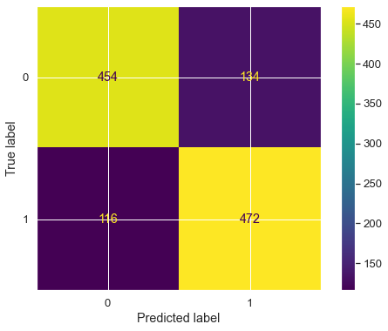
# Classification Report - Train data
print(classification_report(Y_train_SM, Y_train_grid_predict))
precision recall f1-score support
0 0.80 0.77 0.78 588
1 0.78 0.80 0.79 588
accuracy 0.79 1176
macro avg 0.79 0.79 0.79 1176
weighted avg 0.79 0.79 0.79 1176
# Confusion Matrix - Test data
plot_confusion_matrix(best_LR_model, normalized_X_test, Y_test)
<sklearn.metrics._plot.confusion_matrix.ConfusionMatrixDisplay at 0x2364f025ca0>
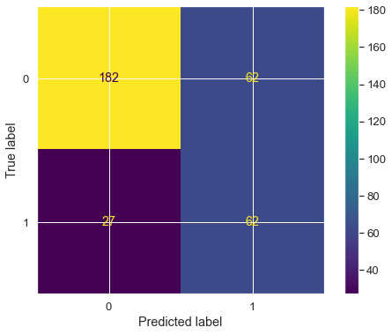
# Classification Report - Test data
print(classification_report(Y_test, Y_test_grid_predict))
precision recall f1-score support
0 0.87 0.75 0.80 244
1 0.50 0.70 0.58 89
accuracy 0.73 333
macro avg 0.69 0.72 0.69 333
weighted avg 0.77 0.73 0.74 333
There is no change in the recall values and other matrices as well after using GridSearchCV.
This might not be the best model. We will check other models as well.

KNN Model (k-nearest neighbors)
We will be building KNN model on re-sampled train sets.
# Importing KNeighboursClassifier
KNN_model = KNeighborsClassifier()
KNN_model.fit(X_train_SM, Y_train_SM)
KNeighborsClassifier()
# Predicting the model on Train set and check the model score
predicted_labels = KNN_model.predict(X_train_SM)
KNN_model_score = KNN_model.score(X_train_SM, Y_train_SM)
predicted_labels_test = KNN_model.predict(normalized_X_test)
KNN_model_score_test = KNN_model.score(normalized_X_test, Y_test)
KNN_model_score
0.9914965986394558
KNN_model_score_test
0.9159159159159159
Accuracy is quite good. Let see the other metrics.

Classification Report and Confusion Matrix :-
# For train data
print('Confusion Matrix\n')
print(metrics.confusion_matrix(Y_train_SM, predicted_labels))
print('Classification Report\n')
print(metrics.classification_report(Y_train_SM, predicted_labels))
Confusion Matrix
[[578 10]
[ 0 588]]
Classification Report
precision recall f1-score support
0 1.00 0.98 0.99 588
1 0.98 1.00 0.99 588
accuracy 0.99 1176
macro avg 0.99 0.99 0.99 1176
weighted avg 0.99 0.99 0.99 1176
# For test data
print('Confusion Matrix\n')
print(metrics.confusion_matrix(Y_test, predicted_labels_test))
print('Classification Report\n')
print(metrics.classification_report(Y_test, predicted_labels_test))
Confusion Matrix
[[216 28]
[ 0 89]]
Classification Report
precision recall f1-score support
0 1.00 0.89 0.94 244
1 0.76 1.00 0.86 89
accuracy 0.92 333
macro avg 0.88 0.94 0.90 333
weighted avg 0.94 0.92 0.92 333
Recall Value is much better than the logistic Regression model.
Recall for the minority class(1) is 80 which is good, and also the accuracy is 79 that is also a good score. Now let's check the AUC ROC Curve and other metrics as well.

AUC ROC Curve :-
# AUC ROC Curve on Train data
probs_train = KNN_model.predict_proba(X_train_SM)
probs_train = probs_train[:, 1]
auc=roc_auc_score(Y_train_SM,probs_train)
print("Area Under Curve: %.3f " % auc)
train_fpr ,train_tpr, train_thresholds= roc_curve(Y_train_SM, probs_train)
plt.plot([0,1],[0,1],linestyle='--')
plt.plot(train_fpr,train_tpr);
Area Under Curve: 1.000
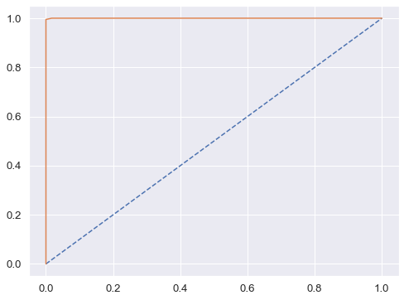
Since, the AUC = 100%, which is too good and it means that the KNN based classifier's performance is better for the model at distinguishing between the positive and negative classes.

Naive Bayes Model
# Fit the model into training data
NB_model = GaussianNB()
NB_model.fit(X_train_SM, Y_train_SM)
GaussianNB()

Let see the performance of our model with training data :-
NB_train_predict = NB_model.predict(X_train_SM)
print("Model Accuracy: {0:.2f}".format(metrics.accuracy_score(Y_train_SM, NB_train_predict)))
Model Accuracy: 0.73

Let see the performance of our model with training data :-
NB_test_predict = NB_model.predict(normalized_X_test)
print("Model Accuracy: {0:.2f}".format(metrics.accuracy_score(Y_test, NB_test_predict)))
Model Accuracy: 0.70

Confusion Matrix & Classification Report :-
print("Confusion Matrix:\n")
CM = metrics.confusion_matrix(Y_test, NB_test_predict, labels=[1, 0])
df_CM = pd.DataFrame(CM, index = [i for i in ["1","0"]],
columns = [i for i in ["Predict 1","Predict 0"]])
# Plotting the matrix
plt.figure(figsize = (8,6))
sns.heatmap(df_CM, annot=True)
Confusion Matrix:
<AxesSubplot:>
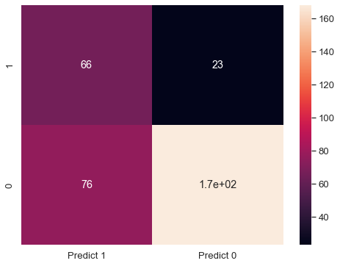
print("Classification Report")
print(metrics.classification_report(Y_test, NB_test_predict, labels=[1, 0]))
Classification Report
precision recall f1-score support
1 0.46 0.74 0.57 89
0 0.88 0.69 0.77 244
accuracy 0.70 333
macro avg 0.67 0.72 0.67 333
weighted avg 0.77 0.70 0.72 333

2. Model Tuning
- Ensemble modeling, wherever applicable.
- Any other model tuning measures(if applicable).
- Interpretation of the most optimum model and its implication on the business.

Random Forest
rfcl = RandomForestClassifier(n_estimators=301, oob_score = True, max_depth = 10, max_features = 5, min_samples_leaf = 50, min_samples_split=110)
rfcl = rfcl.fit(X_train_SM, Y_train_SM)
n_estimators = number of trees, that we want to build within the RandomForestClassifier.
Out of bag (OOB) score is a way of validating the Random forest model. OOB score is computed as the number of correctly predicted rows from the out of bag sample.
max_features will be used to select randomly features from the available number of features.
rfcl
RandomForestClassifier(max_depth=10, max_features=5, min_samples_leaf=50,
min_samples_split=110, n_estimators=301, oob_score=True)
rfcl.oob_score_
0.826530612244898
#Checking the error rate in %:
print('Error_rate(in %) :', 1- (rfcl.oob_score_)) #OOB Error is the number of wrongly classifying the OOB Sample.
Error_rate(in %) : 0.173469387755102
For the above specified grid parameters, we got the rfcl model with oob score around 83% and error rate 17%, which shows the model is good to go for further evaluation.

Getting the Feature Importances :-
print (pd.DataFrame(rfcl.feature_importances_, columns = ["Imp"],
index = X_train_SM.columns).sort_values('Imp',ascending=False))
Imp
YA_view_on_CP 0.21
TL_rec_on_OS_checkin 0.18
following_CP_Yes 0.16
Adult_flag 0.10
DA_mins_spend_on_CP 0.09
TL_done_on_OS_checkin 0.07
week_since_last_OS_checkin 0.05
travelling_network_rating 0.04
YA_OS_checkin 0.04
YA_comment_on_CP 0.04
members_in_fam 0.02
working_flag_Yes 0.00
pref_loc_type_Big Cities 0.00
pref_loc_type_Other 0.00

Let's Now use Ensemble techniques : Bagging, Ada Boosting, GradientBoost :-
#Let's first look by use Bagging
#we will be using random forest as base_estimator
bgcl = BaggingClassifier(base_estimator=rfcl, n_estimators=50,random_state=1)
# Fit the model into training data
bgcl = bgcl.fit(X_train_SM, Y_train_SM)
# Let's predict on test set
Y_test_predict = bgcl.predict(normalized_X_test)
print(bgcl.score(normalized_X_test , Y_test))
cm=metrics.confusion_matrix(Y_test, Y_test_predict,labels=[0, 1])
df_cm = pd.DataFrame(cm, index = [i for i in ["No","Yes"]],
columns = [i for i in ["No","Yes"]])
plt.figure(figsize = (7,5))
sns.heatmap(df_cm, annot=True ,fmt='g')
0.7297297297297297
<AxesSubplot:>
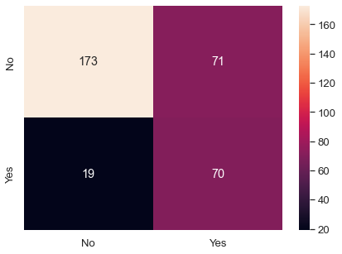

Ada Boosting
# Defining the ada boosting classifier
abcl = AdaBoostClassifier(n_estimators=10, random_state=1)
#fit the model to the train data
abcl = abcl.fit(X_train_SM, Y_train_SM)
Y_predict_1 = abcl.predict(normalized_X_test)
print(abcl.score(normalized_X_test , Y_test))
cm = metrics.confusion_matrix(Y_test, Y_predict_1,labels=[0, 1])
df_cm_1 = pd.DataFrame(cm, index = [i for i in ["No","Yes"]],
columns = [i for i in ["No","Yes"]])
plt.figure(figsize = (7,5))
sns.heatmap(df_cm_1, annot=True ,fmt='g')
0.44744744744744747
<AxesSubplot:>
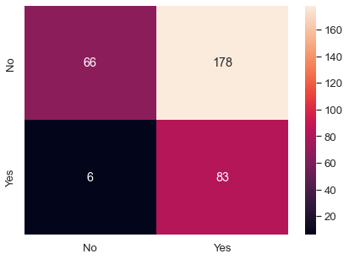

Gradient Boost
gbcl = GradientBoostingClassifier(n_estimators = 50,random_state=1)
gbcl = gbcl.fit(X_train_SM, Y_train_SM)
Y_predict_2 = gbcl.predict(normalized_X_test)
print(gbcl.score(normalized_X_test, Y_test))
0.6126126126126126
cm = metrics.confusion_matrix(Y_test, Y_predict_2,labels=[0, 1])
df_cm_2 = pd.DataFrame(cm, index = [i for i in ["No","Yes"]],
columns = [i for i in ["No","Yes"]])
plt.figure(figsize = (7,5))
sns.heatmap(df_cm_2, annot=True ,fmt='g')
<AxesSubplot:>
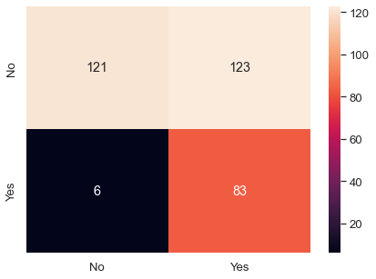

Calculation for Model Building : For Mobile users

Train-Test Split :-
#Now, let's separate dependent and independent variables
x = data_mobile_dummy.drop('Taken_product_Yes', axis=1)
y = data_mobile_dummy[['Taken_product_Yes']]
# Split the data into test and train sets in 70:30 ratio
x_train, x_test, y_train, y_test = train_test_split(x, y, test_size = 0.30, random_state = 11)
print('Shape of x_train:',x_train.shape)
x_train.head().T
Shape of x_train: (6542, 17)
4471 10698 5645 8744 5377
YA_view_on_CP 287.00 403.00 346.00 245.00 301.00
TL_done_on_OS_checkin 22885.00 52192.00 44738.00 48062.00 11554.00
YA_OS_checkin 29.00 4.00 1.00 5.00 1.00
members_in_fam 5.00 2.00 3.00 4.00 4.00
YA_comment_on_CP 58.00 47.00 79.00 61.00 95.00
TL_rec_on_OS_checkin 2461.00 16572.00 10411.00 9687.00 2447.00
week_since_last_OS_checkin 1.00 4.00 6.00 8.00 3.00
travelling_network_rating 4.00 4.00 2.00 2.00 3.00
Adult_flag 0.00 0.00 1.00 0.00 1.00
DA_mins_spend_on_CP 15.00 33.00 19.00 8.00 7.00
pref_loc_type_Big Cities 0.00 0.00 0.00 0.00 0.00
pref_loc_type_Entertainment 0.00 0.00 0.00 0.00 0.00
pref_loc_type_Financial 1.00 0.00 1.00 0.00 1.00
pref_loc_type_Medical 0.00 0.00 0.00 0.00 0.00
pref_loc_type_Other 0.00 0.00 0.00 0.00 0.00
following_CP_Yes 0.00 0.00 1.00 0.00 0.00
working_flag_Yes 0.00 0.00 0.00 1.00 1.00
# Normalization of x_train
normalized_x_train = pd.DataFrame(StandardScaler().fit_transform(x_train),columns = x_train.columns)
print('Shape of y_train:',y_train.shape)
y_train.head().T
Shape of y_train: (6542, 1)
4471 10698 5645 8744 5377
Taken_product_Yes 0 0 0 0 0
print('Shape of x_test:',x_test.shape)
x_test.head().T
Shape of x_test: (2805, 17)
8355 4104 6362 3270 11676
YA_view_on_CP 222.00 301.00 241.00 324.00 205.00
TL_done_on_OS_checkin 11627.00 15717.00 47778.00 19609.00 5545.00
YA_OS_checkin 17.00 16.00 13.00 10.00 1.00
members_in_fam 3.00 3.00 4.00 4.00 3.00
YA_comment_on_CP 55.00 99.00 51.00 96.00 111.00
TL_rec_on_OS_checkin 7995.00 7998.00 4237.00 5301.00 2924.00
week_since_last_OS_checkin 1.00 8.00 2.00 2.00 1.00
travelling_network_rating 1.00 4.00 3.00 2.00 4.00
Adult_flag 0.00 0.00 0.00 1.00 0.00
DA_mins_spend_on_CP 10.00 21.00 9.00 11.00 14.00
pref_loc_type_Big Cities 0.00 0.00 0.00 0.00 0.00
pref_loc_type_Entertainment 0.00 0.00 0.00 0.00 0.00
pref_loc_type_Financial 0.00 1.00 0.00 1.00 0.00
pref_loc_type_Medical 0.00 0.00 0.00 0.00 0.00
pref_loc_type_Other 1.00 0.00 0.00 0.00 0.00
following_CP_Yes 0.00 1.00 0.00 0.00 0.00
working_flag_Yes 0.00 0.00 0.00 0.00 0.00
# Normalization of x_test
normalized_x_test = pd.DataFrame(StandardScaler().fit_transform(x_test),columns = x_test.columns)
print('Shape of y_test:',y_test.shape)
y_test.head()
Shape of y_test: (2805, 1)
Taken_product_Yes
8355 0
4104 0
6362 1
3270 0
11676 0
data_mobile_dummy['Taken_product_Yes'].value_counts()
0 7930
1 1417
Name: Taken_product_Yes, dtype: int64

Need of applying SMOTE :-
As per our analysis, we got to know that the data is more towards the negative side, like majority of the users have not taken our product.This clearly means that data is in imbalance state.
Standard ML techniques such as Decision Tree and Logistic Regression have a bias towards the majority class, and they tend to ignore the minority class. They tend only to predict the majority class, hence, having major misclassification of the minority class in comparison with the majority class. In more technical words, if we have imbalanced data distribution in our dataset then our model becomes more prone to the case when minority class has negligible or very lesser recall.
So we will be using a over sampling technique called SMOTE to handle imbalanced data.

Logistic Regression Model (with default values) : On imbalance data
# Let us first now train the data without handling imbalance problem
LR_mob = LogisticRegression()
# Now let's fit the model on training data
LR_mob.fit(normalized_x_train, y_train)
LogisticRegression()
# Prdecition on training data
y_train_predict = LR_mob.predict(normalized_x_train)
# Prdecition on testing data
y_test_predict = LR_mob.predict(normalized_x_test)
# Getting the predicted classes and probs
y_test_predict_prob = LR_mob.predict_proba(normalized_x_test)
# Model Evaluation - Accuracy on training data
LR_mob.score(normalized_x_train, y_train)
0.8720574747783553
# Classification Report - training data
print(classification_report(y_train, y_train_predict))
precision recall f1-score support
0 0.88 0.99 0.93 5550
1 0.75 0.23 0.36 992
accuracy 0.87 6542
macro avg 0.82 0.61 0.64 6542
weighted avg 0.86 0.87 0.84 6542
# Classification Report - testing data
print(classification_report(y_test, y_test_predict))
precision recall f1-score support
0 0.87 0.98 0.92 2380
1 0.66 0.19 0.30 425
accuracy 0.86 2805
macro avg 0.77 0.59 0.61 2805
weighted avg 0.84 0.86 0.83 2805

Applying SMOTE
Now, we will apply the imbalanced data handling technique, called SMOTE and test it's accuracy and recall results.
SM = SMOTE(random_state = 2)
x_train_SM, y_train_SM = SM.fit_sample(normalized_x_train, y_train)
print('After OverSampling, the shape of x_train:',x_train_SM.shape)
print('After OverSampling, the shape of y_train:',y_train_SM.shape)
After OverSampling, the shape of x_train: (11100, 17)
After OverSampling, the shape of y_train: (11100, 1)

Logistic Regression Model (with default values) : On balanced data - After applying SMOTE - Oversampling
Now we will again make the model again and check the recall values for majority and minority classes.
LR_mob_SM = LogisticRegression()
# Now let's fit the model on train data
LR_mob_SM.fit(x_train_SM, y_train_SM)
LogisticRegression()
# Prdecition - on Train data
y_train_predict_SM = LR_mob_SM.predict(x_train_SM)
# Prdecition - on Test data
y_test_predict_SM = LR_mob_SM.predict(normalized_x_test)
# Model Evaluation - Accuracy on Train data
LR_mob_SM.score(x_train_SM, y_train_SM)
0.7296396396396396
# Classification Report - Train data
print(classification_report(y_train_SM, y_train_predict_SM))
precision recall f1-score support
0 0.73 0.72 0.73 5550
1 0.73 0.74 0.73 5550
accuracy 0.73 11100
macro avg 0.73 0.73 0.73 11100
weighted avg 0.73 0.73 0.73 11100
# Classification Report - Test data
print(classification_report(y_test, y_test_predict_SM))
precision recall f1-score support
0 0.94 0.72 0.82 2380
1 0.32 0.74 0.45 425
accuracy 0.72 2805
macro avg 0.63 0.73 0.63 2805
weighted avg 0.85 0.72 0.76 2805
Now the difference is clear, that after over-sampling, the accuracy has been decreased from 85% to 73%.
But as we know that the accuracy is not the good predictor here in our case because we are dealing with less classes and it is also a classification algorithm.
So here we will focus more on improving our recall. Now, the recall for the minority class has been increased a lot, and it is 70%. That is very good. But the recall for the majority class has been decreased, this is due the fact that now that there is a balance in both the classes.
Recall value for the minority class(1) is 0.70 which is a good prediction, since our model has predicted 70% of the 1's as 1's and only 30% of the prediction were wrong.

Logistic Regression Model (Customized Values) : On balanced data - After applying SMOTE - Oversampling
As we have build the previous model with it's default values. There might be chances of more better model than this, with some customized parameters for the logistic regression model.
We can improve the model by tuning the hyper-parameters of the model. So here we will use 'GridSearchCV' method to get the best parameters and then we would want to test out in the model again.
# Fit the Logistic Regression model
LR_mob_SM_custom = LogisticRegression(solver='lbfgs', penalty='none', max_iter=100000, n_jobs=2, verbose=True)
LR_mob_SM_custom.fit(x_train_SM, y_train_SM)
[Parallel(n_jobs=2)]: Using backend LokyBackend with 2 concurrent workers.
[Parallel(n_jobs=2)]: Done 1 out of 1 | elapsed: 1.9s finished
LogisticRegression(max_iter=100000, n_jobs=2, penalty='none', verbose=True)
# Prdecition - on Train data
y_train_predict_SM_custom = LR_mob_SM_custom.predict(x_train_SM)
# Prdecition - on Test data
y_test_predict_SM_custom = LR_mob_SM_custom.predict(normalized_x_test)
# Model Evaluation - Accuracy - for Train data
LR_mob_SM_custom.score(x_train_SM, y_train_SM)
0.7296396396396396
# Classification Report - Train data
print(classification_report(y_train_SM, y_train_predict_SM_custom))
precision recall f1-score support
0 0.73 0.72 0.73 5550
1 0.73 0.74 0.73 5550
accuracy 0.73 11100
macro avg 0.73 0.73 0.73 11100
weighted avg 0.73 0.73 0.73 11100
# Classification Report - Test data
print(classification_report(y_test, y_test_predict_SM_custom))
precision recall f1-score support
0 0.94 0.72 0.82 2380
1 0.32 0.74 0.45 425
accuracy 0.72 2805
macro avg 0.63 0.73 0.63 2805
weighted avg 0.85 0.72 0.76 2805

Confusion Matrix, AUC, ROC for the Model :-
## Confusion matrix - Train data
plot_confusion_matrix(LR_mob_SM, x_train_SM, y_train_SM)
<sklearn.metrics._plot.confusion_matrix.ConfusionMatrixDisplay at 0x23650cda2b0>
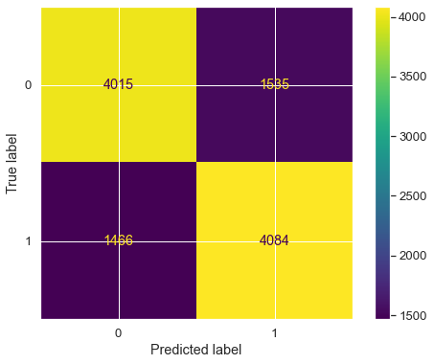
So, True Positives are coming here is 472, that means 472 times our model has predicted correctly, that means it has predicted 1 as 1, and only 116 times it has predicted incorrectly.
Similarly, True Negatives are 454 that means 454 times it has predicted 0 as 0 and only 116 times, the prediction was incorrect.
## Confusion matrix - Test data
plot_confusion_matrix(LR_mob_SM, normalized_x_test, y_test)
<sklearn.metrics._plot.confusion_matrix.ConfusionMatrixDisplay at 0x23650d71fa0>
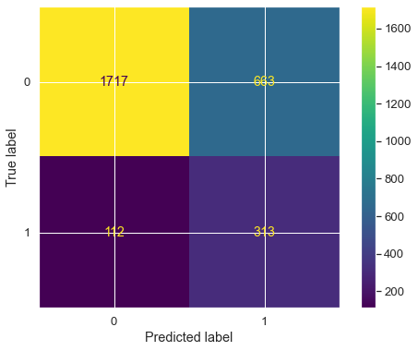
So, in test data, True Positives are coming here is 62, that means 62 times our model has predicted correctly, that means it has predicted 1 as 1, and only 27 times it has predicted incorrectly.
Similarly, True Negatives are 182 that means 182 times it has predicted 0 as 0 and only 62 times, the prediction was incorrect.
# Predicting Probabilities
probs = LR_mob_SM.predict_proba(x_train_SM)
# Keep probabilities for the positive outcome only
probs = probs[:, 1]
# Calculate Area Under Curve
auc = roc_auc_score(y_train_SM, probs)
print('AUC: %.3f' % auc)
# Calculate ROC curve
train_fpr, train_tpr, train_thresholds = roc_curve(y_train_SM, probs)
plt.rcParams["figure.figsize"] = (8,6)
plt.plot([0, 1], [0, 1], linestyle='--')
# Plot the roc curve for the model
plt.plot(train_fpr, train_tpr);
AUC: 0.794
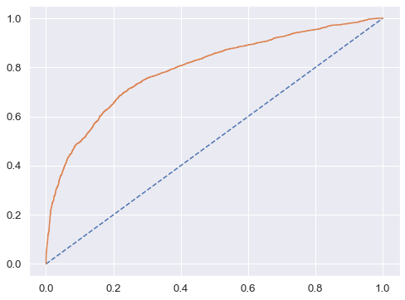
#Accuracy score - for Test data
acc_test = LR_mob_SM.score(normalized_x_test, y_test)
acc_test
0.7237076648841355
So in the above model, the area under the curve is 86% that means the overall model performance is good.
Also, the confusion matrix and classification report the LR_mob_SM Logistic Regression Model is giving the good results.

Using GridSearchCV for Logistic Regression :-
grid = {'penalty':['l2','none'], 'solver':['sag','lbfgs'], 'tol':[0.0001,0.00001]}
LR_mob_grid = LogisticRegression(max_iter=10000, n_jobs=2)
grid_search = GridSearchCV(estimator=LR_mob_grid, param_grid = grid, cv=3, n_jobs=-1, scoring='f1')
grid_search.fit(x_train_SM, y_train_SM)
GridSearchCV(cv=3, estimator=LogisticRegression(max_iter=10000, n_jobs=2),
n_jobs=-1,
param_grid={'penalty': ['l2', 'none'], 'solver': ['sag', 'lbfgs'],
'tol': [0.0001, 1e-05]},
scoring='f1')
print('Best Parameters from GridSearch:',grid_search.best_params_)
print('\nBest estimator from GridSearch:',grid_search.best_estimator_)
best_LR_mob_model = grid_search.best_estimator_
Best Parameters from GridSearch: {'penalty': 'l2', 'solver': 'sag', 'tol': 0.0001}
Best estimator from GridSearch: LogisticRegression(max_iter=10000, n_jobs=2, solver='sag')
# Prediction - Train data
y_train_grid_predict = best_LR_mob_model.predict(x_train_SM)
y_test_grid_predict = best_LR_mob_model.predict(normalized_x_test)
# Getting the probabilities - Test data
y_test_grid_predict_prob = best_LR_mob_model.predict_proba(normalized_x_test)
pd.DataFrame(y_test_grid_predict_prob).head()
0 1
0 0.54 0.46
1 0.15 0.85
2 0.57 0.43
3 0.80 0.20
4 0.60 0.40
# Confusion Matrix - Train data
plot_confusion_matrix(best_LR_mob_model, x_train_SM, y_train_SM)
<sklearn.metrics._plot.confusion_matrix.ConfusionMatrixDisplay at 0x23650d7e670>
# Classification Report - Train data
print(classification_report(y_train_SM, y_train_grid_predict))
precision recall f1-score support
0 0.73 0.72 0.73 5550
1 0.73 0.74 0.73 5550
accuracy 0.73 11100
macro avg 0.73 0.73 0.73 11100
weighted avg 0.73 0.73 0.73 11100
# Confusion Matrix - Test data
plot_confusion_matrix(best_LR_mob_model, normalized_x_test, y_test)
<sklearn.metrics._plot.confusion_matrix.ConfusionMatrixDisplay at 0x23650bf02e0>
# Classification Report - Test data
print(classification_report(y_test, y_test_grid_predict))
precision recall f1-score support
0 0.94 0.72 0.82 2380
1 0.32 0.74 0.45 425
accuracy 0.72 2805
macro avg 0.63 0.73 0.63 2805
weighted avg 0.85 0.72 0.76 2805

KNN Model (k-nearest neighbors)
We will be building KNN model on re-sampled train sets.
# Importing KNeighboursClassifier
KNN_mob_model = KNeighborsClassifier()
KNN_mob_model.fit(x_train_SM, y_train_SM)
KNeighborsClassifier()
#let's predict the model on train set and check the model score
predicted_labels = KNN_mob_model.predict(x_train_SM)
KNN_mob_model_score = KNN_mob_model.score(x_train_SM, y_train_SM)
KNN_mob_model_score
0.9808108108108108

Classification Report & Confusion Matrix :-
print('Confusion Matrix\n')
print(metrics.confusion_matrix(y_train_SM, predicted_labels))
print('Classification Report\n')
print(metrics.classification_report(y_train_SM, predicted_labels))
Confusion Matrix
[[5342 208]
[ 5 5545]]
Classification Report
precision recall f1-score support
0 1.00 0.96 0.98 5550
1 0.96 1.00 0.98 5550
accuracy 0.98 11100
macro avg 0.98 0.98 0.98 11100
weighted avg 0.98 0.98 0.98 11100

AUC ROC Curve on Train data :-
probs_train = KNN_mob_model.predict_proba(x_train_SM)
probs_train = probs_train[:, 1]
auc=roc_auc_score(y_train_SM,probs_train)
print("Area Under Curve: %.3f " % auc)
train_fpr ,train_tpr, train_thresholds= roc_curve(y_train_SM, probs_train)
plt.plot([0,1],[0,1],linestyle='--')
plt.plot(train_fpr,train_tpr);
Area Under Curve: 1.000
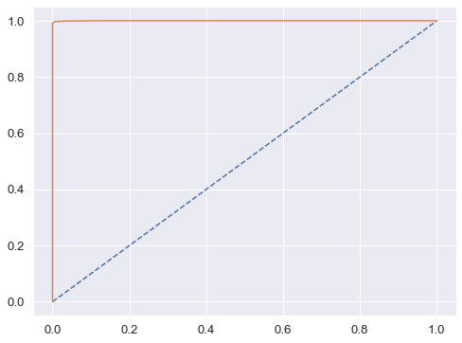
ss

Naive Bayes Model
# Fit the model into training data
NB_mob_model = GaussianNB()
NB_mob_model.fit(x_train_SM, y_train_SM)
GaussianNB()
NB_train_predict = NB_mob_model.predict(x_train_SM)
print("Model Accuracy: {0:.2f}".format(metrics.accuracy_score(y_train_SM, NB_train_predict)))
Model Accuracy: 0.69
# Prediction - on Test data
NB_test_predict = NB_mob_model.predict(normalized_x_test)
print("Model Accuracy: {0:.2f}".format(metrics.accuracy_score(y_test, NB_test_predict)))
Model Accuracy: 0.66
# Confusion Matrix
print("Confusion Matrix:\n")
CM = metrics.confusion_matrix(y_test, NB_test_predict, labels=[1, 0])
df_CM = pd.DataFrame(CM, index = [i for i in ["1","0"]],
columns = [i for i in ["Predict 1","Predict 0"]])
Confusion Matrix:
# Plotting the matrix
plt.figure(figsize = (8,6))
sns.heatmap(df_CM, annot=True)
print("Classification Report")
print(metrics.classification_report(y_test, NB_test_predict, labels=[1, 0]))
Classification Report
precision recall f1-score support
1 0.27 0.73 0.40 425
0 0.93 0.65 0.77 2380
accuracy 0.66 2805
macro avg 0.60 0.69 0.58 2805
weighted avg 0.83 0.66 0.71 2805
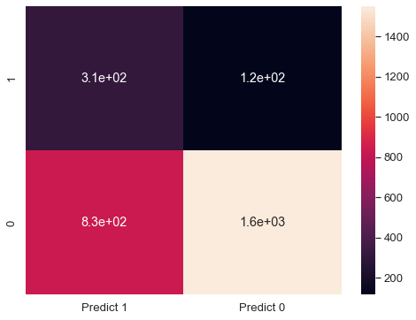

2. Model Tuning
- Ensemble modeling, wherever applicable.
- Any other model tuning measures(if applicable).
- Interpretation of the most optimum model and its implication on the business.

Random Forest
rfcl_mob = RandomForestClassifier(n_estimators=301, oob_score = True, max_depth = 10, max_features = 5, min_samples_leaf = 50, min_samples_split=110)
rfcl_mob = rfcl_mob.fit(x_train_SM, y_train_SM)
n_estimators = number of trees, that we want to build within the RandomForestClassifier.
Out of bag (OOB) score is a way of validating the Random forest model. OOB score is computed as the number of correctly predicted rows from the out of bag sample.
max_features will be used to select randomly features from the available number of features.
rfcl_mob
RandomForestClassifier(max_depth=10, max_features=5, min_samples_leaf=50,
min_samples_split=110, n_estimators=301, oob_score=True)
rfcl_mob.oob_score_
0.8774774774774775
#Checking the error rate in %:
print('Error_rate(in %) :', 1- (rfcl_mob.oob_score_)) #OOB Error is the number of wrongly classifying the OOB Sample.
Error_rate(in %) : 0.12252252252252249
For the above specified grid parameters, we got the rfcl_mob model with oob score around 83% and error rate 17%, which shows the model is good to go for further evaluation.

Getting the Feature Importances :-
print (pd.DataFrame(rfcl_mob.feature_importances_, columns = ["Imp"],
index = x_train_SM.columns).sort_values('Imp',ascending=False))
Imp
following_CP_Yes 0.19
TL_rec_on_OS_checkin 0.17
Adult_flag 0.14
YA_view_on_CP 0.09
week_since_last_OS_checkin 0.08
DA_mins_spend_on_CP 0.08
TL_done_on_OS_checkin 0.07
travelling_network_rating 0.05
YA_OS_checkin 0.05
members_in_fam 0.03
YA_comment_on_CP 0.03
working_flag_Yes 0.00
pref_loc_type_Entertainment 0.00
pref_loc_type_Medical 0.00
pref_loc_type_Financial 0.00
pref_loc_type_Big Cities 0.00
pref_loc_type_Other 0.00

Let's Now use Ensemble techniques : Bagging, Ada Boosting, GradientBoost :-
#Let's first look by use Bagging
#we will be using random forest as base_estimator
bgcl_mob = BaggingClassifier(base_estimator=rfcl_mob, n_estimators=50,random_state=1)
# Fit the model into training data
bgcl_mob = bgcl_mob.fit(x_train_SM, y_train_SM)
# Let's predict on test set
y_test_predict = bgcl_mob.predict(normalized_x_test)
print(bgcl_mob.score(normalized_x_test , y_test))
0.8156862745098039
cm=metrics.confusion_matrix(y_test, y_test_predict,labels=[0, 1])
df_cm = pd.DataFrame(cm, index = [i for i in ["No","yes"]],
columns = [i for i in ["No","yes"]])
plt.figure(figsize = (7,5))
sns.heatmap(df_cm, annot=True ,fmt='g')
<AxesSubplot:>
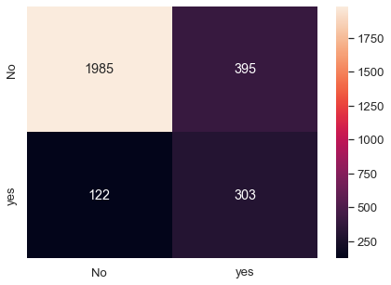

Ada Boosting
# Defining the ada boosting classifier
abcl_mob = AdaBoostClassifier(n_estimators=10, random_state=1)
#fit the model to the train data
abcl_mob = abcl_mob.fit(x_train_SM, y_train_SM)
# Prediction on - Test data
y_predict_1 = abcl_mob.predict(normalized_x_test)
print(abcl_mob.score(normalized_x_test , y_test))
0.6880570409982175
cm = metrics.confusion_matrix(y_test, y_predict_1,labels=[0, 1])
df_cm_1 = pd.DataFrame(cm, index = [i for i in ["No","yes"]],
columns = [i for i in ["No","yes"]])
plt.figure(figsize = (7,5))
sns.heatmap(df_cm_1, annot=True ,fmt='g')
<AxesSubplot:>
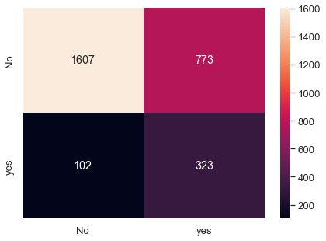

Gradient Boost
gbcl_mob = GradientBoostingClassifier(n_estimators = 50,random_state=1)
# Fit the model on Train data
gbcl_mob = gbcl_mob.fit(x_train_SM, y_train_SM)
# Prediction - on Test data
y_predict_2 = gbcl_mob.predict(normalized_x_test)
print(gbcl_mob.score(normalized_x_test, y_test))
0.5572192513368984
cm = metrics.confusion_matrix(y_test, y_predict_2,labels=[0, 1])
df_cm_2 = pd.DataFrame(cm, index = [i for i in ["No","yes"]],
columns = [i for i in ["No","yes"]])
plt.figure(figsize = (7,5))
sns.heatmap(df_cm_2, annot=True ,fmt='g')
<AxesSubplot:>
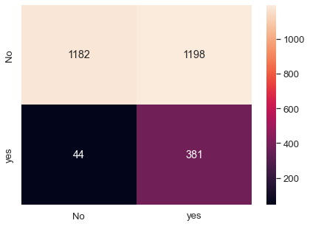
import shap
---------------------------------------------------------------------------
ModuleNotFoundError Traceback (most recent call last)
~\AppData\Local\Temp/ipykernel_1408/3975714860.py in <module>
----> 1 import shap
ModuleNotFoundError: No module named 'shap'

